Laboratory #3: Working with geographic databases

**Purpose:** The purpose of this lab is to provide you with experience in creating a geographic database.

**Learning Outcomes:** By the end of this lab, you will be able to:

* Create a geodatabase.
* Import data to the geodatabase.
* Create a relationship class within the geodatabase.
* Answer spatial questions using aspatial ad-hoc queries.
* Demonstrate calculating fields.
* Demonstrate map creation.

**Procedure:**

1. Read and work through the examples.
2. Answer the questions at the end of the lab.

**Data/Materials:**

* All data are provided in lab3.zip. You can use these data if you do not have access to Scholars Geoportal.

**Assignment:**

* Answer the questions (#1-6) in the spaces provided.
* The total marks available for this assignment = 27 marks for 12.5% total course grade.
* All lab assignments must be completed and handed in individually.

**Format:**

* Students will hand in questions with completed answers.

**Tables and figures should be produced to the standards of the Department of Geography, Environment and Geomatics, University of Ottawa.**

**For guidelines on proper formatting and presentation of tables and figures, please see the introductory section of this lab manual.**

Q1: How do I download data from the Scholars GeoPortal?

The Scholars GeoPortal is a hardware and software infrastructure that gives Ontario-based students and researchers access to large-scale geospatial datasets. These include land-based vector data (water, cultural features, etc.), census data, and some raster imagery.

You can only download certain data from Scholars Geoportal when you are authenticated through a university in Ontario, either by accessing the data on campus or by using a VPN. If you can, you should follow the instructions below to download the data for this exercise. Learning how to download data from Scholars GeoPortal is very useful.

*Note: if you cannot access Scholars GeoPortal, you can find all the same data sets in the file called lab3.zip, you just need to sort them out based on the filenames.*

To download the census tracts for Ottawa-Gatineau that you need for this exercise:

1. Goto <http://geo2.scholarsportal.info/>
2. In the Search tab, search box type “Census tracts 2011” and click the Search button:

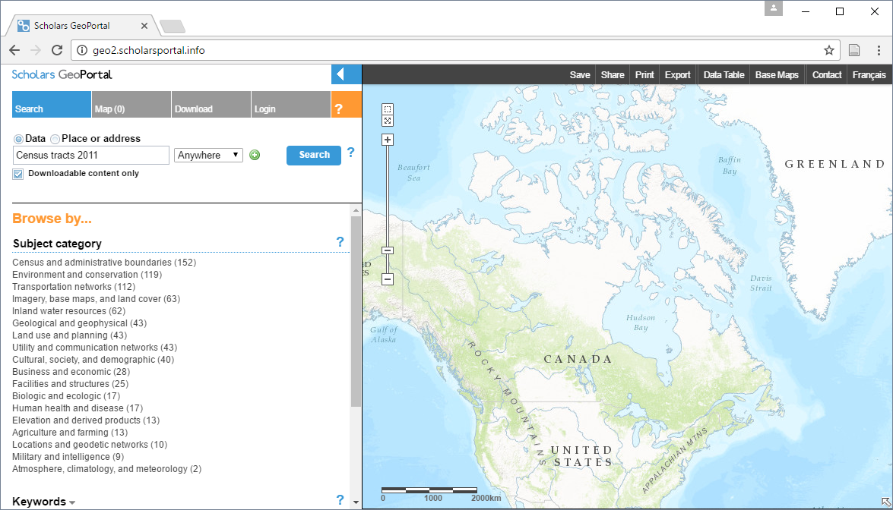

1. When the search is complete, you will see the following list of items (note that the list may not be in the same order as you see below). Find the “Cartographic Boundary Files (CBF), 2011 Census” item:

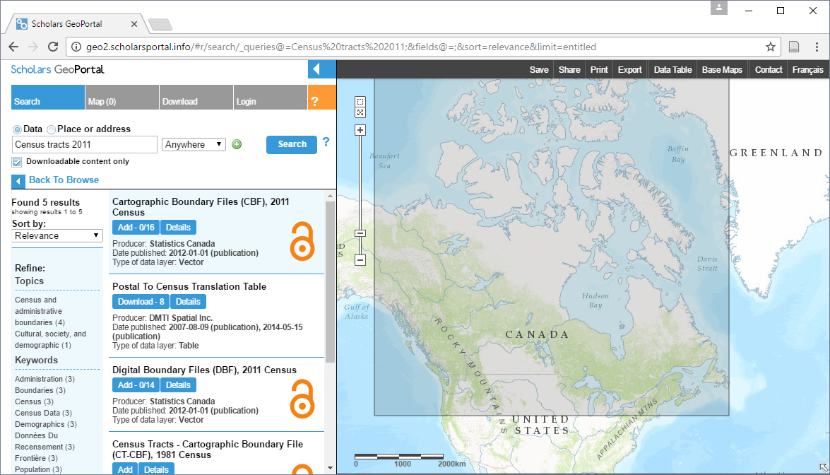

1. For the “Cartographic Boundary Files (CBF), 2011 Census” click on the Add – 0/20 button and you will see another list. In this list, look for the item called “Census Tracts *Vector*“ and click the Add button and your map will look something like this:

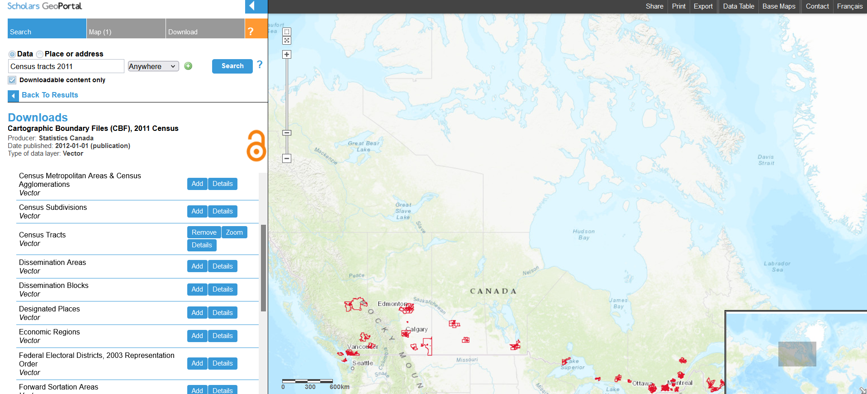

1. You can zoom into the Ottawa region using the zoom tools:

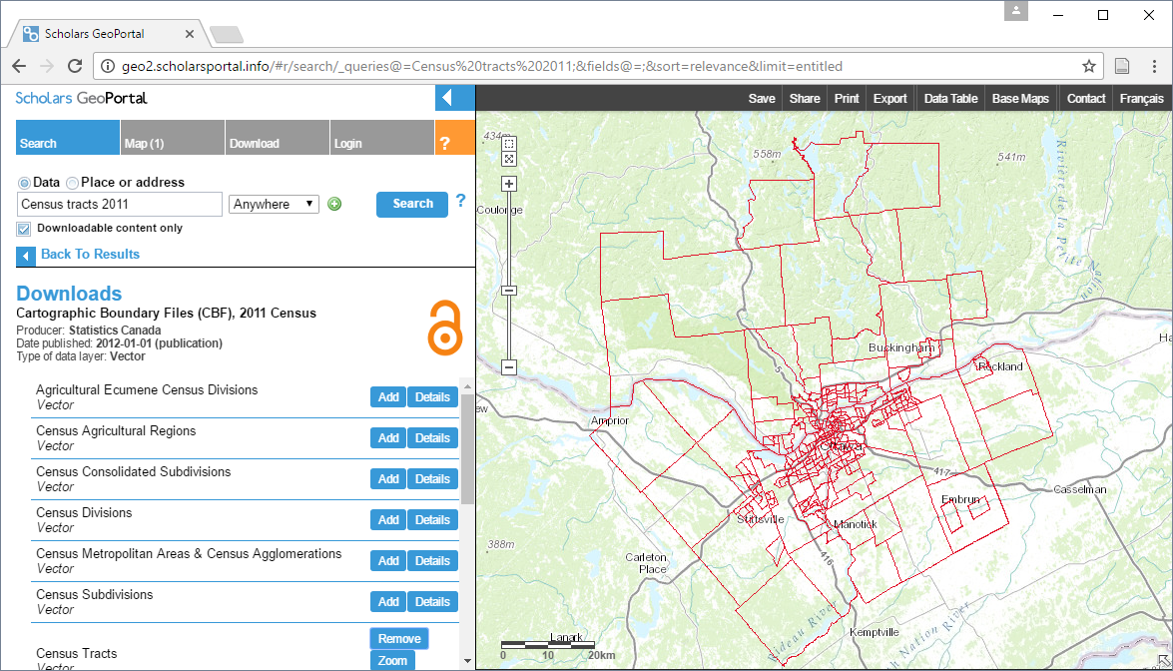

1. Now, click on the Download tab at the top of the page.
2. Do the following:
   1. Select “Download by area of interest”.
   2. Select “Draw an area”.
   3. Click on the rectangle tool.
   4. Click and drag a box around the Ottawa-Gatineau region so that all red lines are completely contained within the box you draw.
   5. In the “Choose an output file format” (vector data only)” section, choose File Geodatabase – (.gdb).
   6. In the “Choose an output coordinate system (vector data only)” section, choose UTM – Zone 18N.

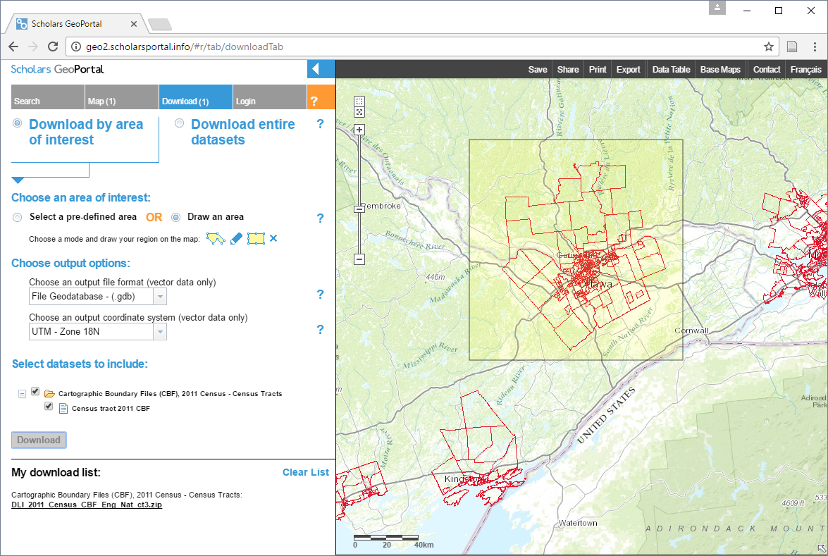

1. 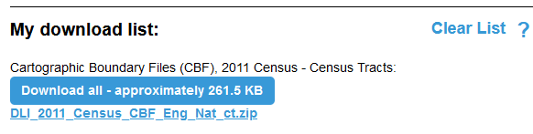Click on the Download button. When the download is prepared, you will see a .zip file for download in the ‘My download list’: section.
2. Download the file by clicking the **link with the bolded and underlined blue text**, and unzip the file to a location that you will remember.
3. Open ArcGIS Pro and add the folder you unzipped in the previous step.
4. In the **data.gdb** geodatabase within that folder, you will find a single feature class that will be called something to the effect of “DLI_2011_Census…. In the Catalog pane, rename that feature class to “Census_tracts” (right click on the Feature Class and choose “Rename”)  
     
   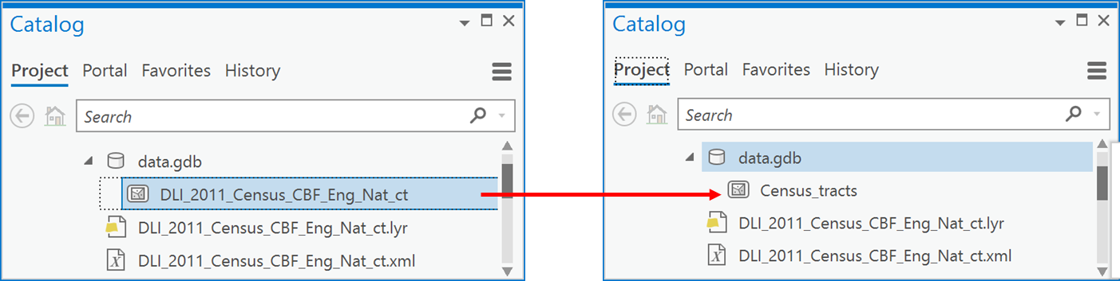
5. Now, add “Census_data” to a new map:

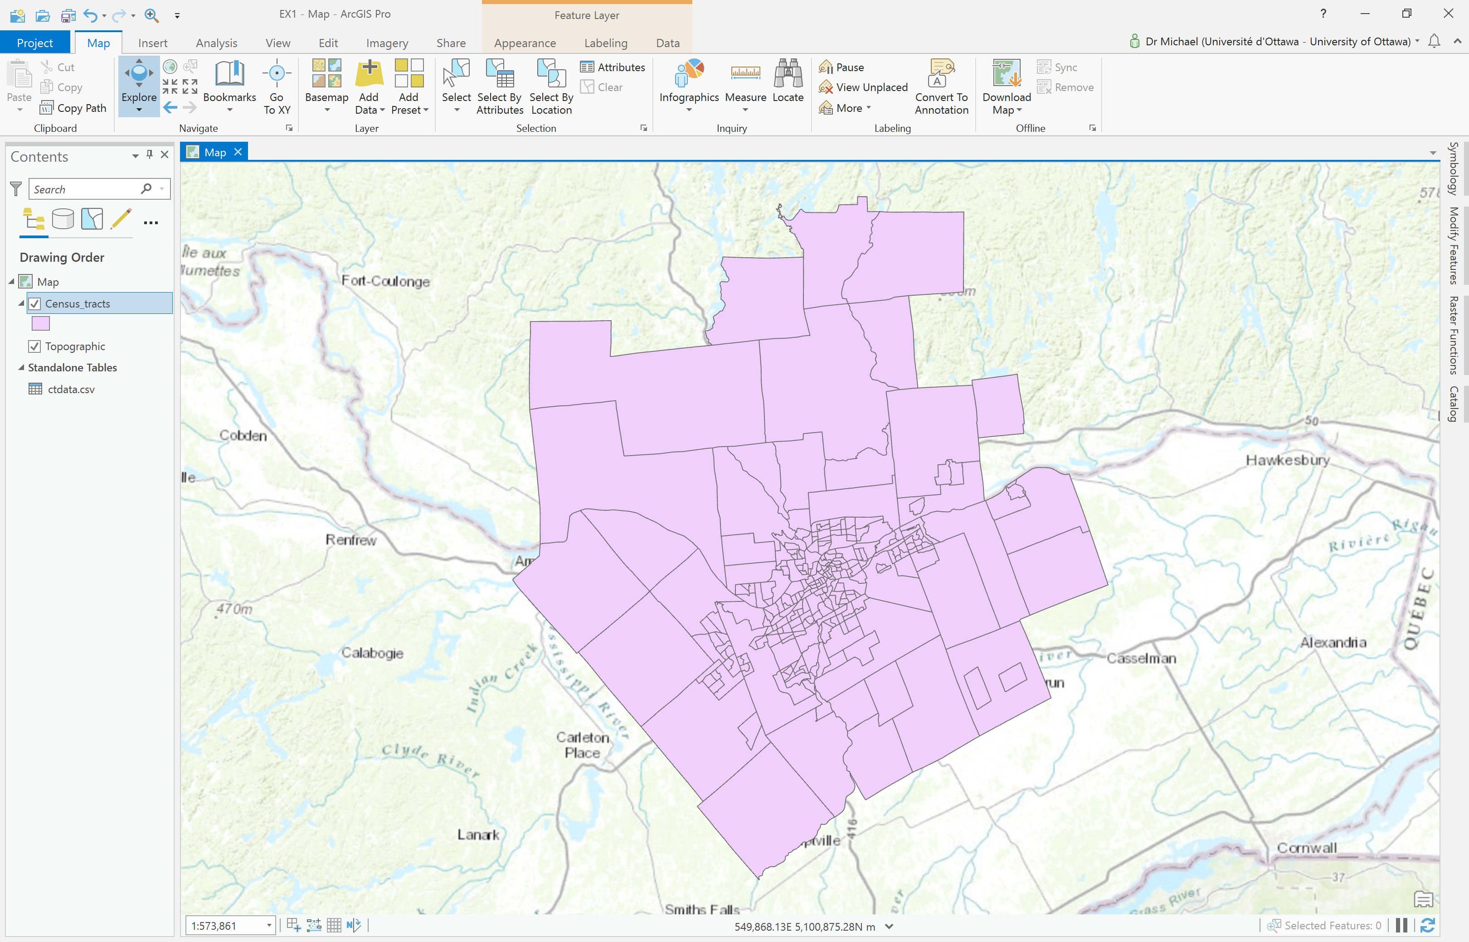

1. Open the attribute table. In the attribute table, you can see that the columns or fields only identify each of the census tracts. In particular, the **CTUID** field is important because it contains a unique identifier for each census tract.

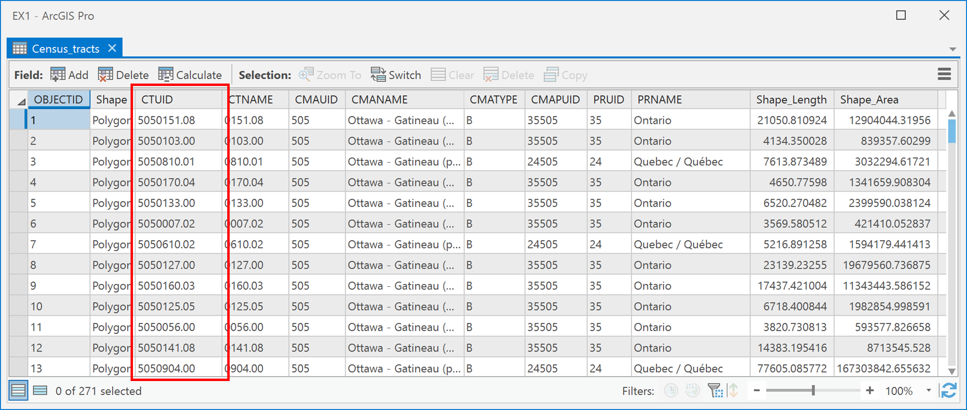

Q2: Where do I get data to go with the Census Tracts?

Data for each census tract can be accessed through the Canadian Census Analyzer web-tool, which is available from campus or when you are authenticated with the uOttawa VPN. The census analyzer is not a data source, but rather an interface or web program. The data source is always the institution, organization or person that created the data, in this case Statistics Canada.

*Note: As for the data from Scholars GeoPortal, if you cannot access data from the Canadian Census Analyzer, you can find the data you need in the lab3.zip file.*

1. Go to <http://datacentre.chass.utoronto.ca/census/>
2. Next, under Census Profiles Tables, choose ‘Census Tract’

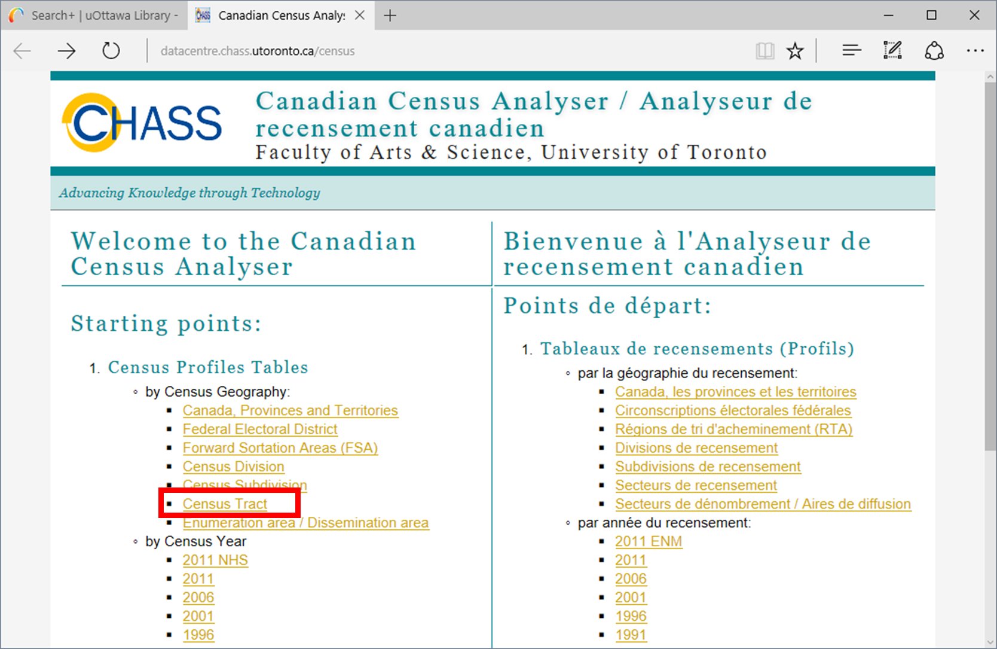

1. Now you will see a list of dates, and we are interested in the 2011 Census data. There are two types of 2011 census data:

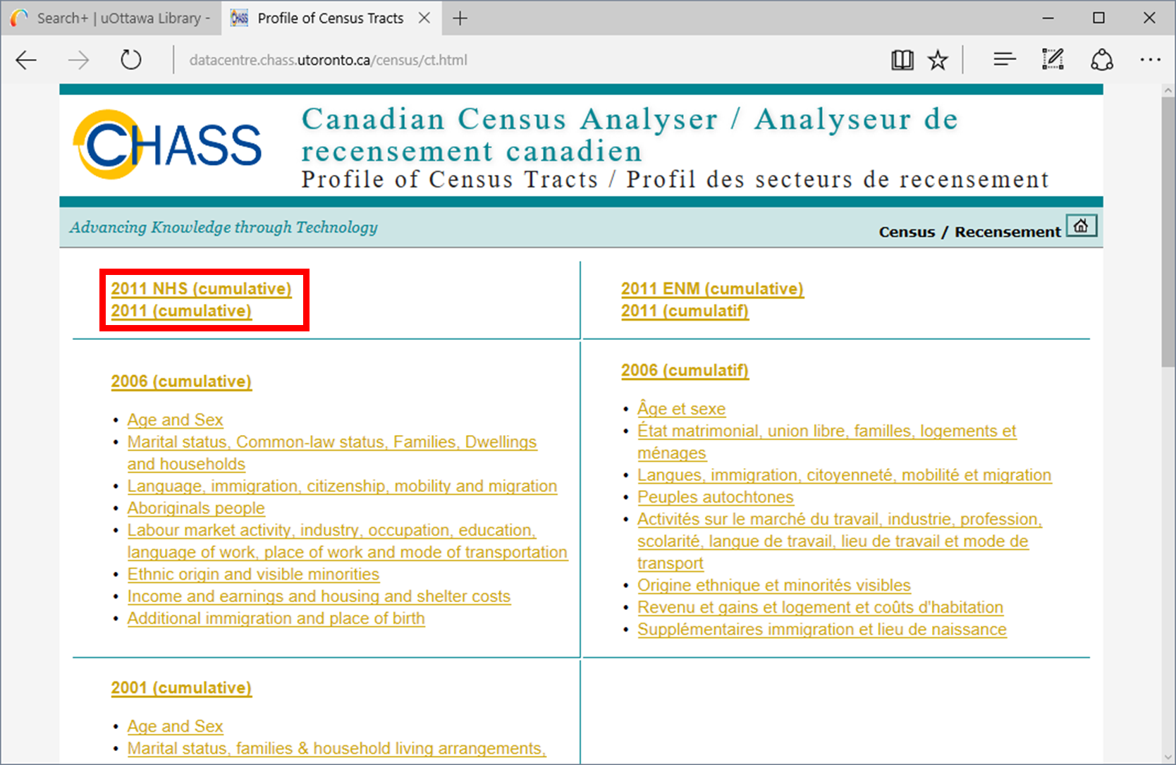

* 1. 2011 (cumulative): the full census that everyone fills out, which contains data about language, age, sex, marital status and population and age breakdowns.
  2. 2011 NHS (cumulative): the long-form census data that contains some 1000+ variables that are reported by approximately 20% of the population and contain details about work, transportation etc.

Data is available at the census tract level for both types of census data.

1. Click on ‘2011 (cumulative)’, then, under “Step 1: Specify Census Geography for retrieval”, put a checkmark in ‘O’ and below that, a check mark in ‘Ottawa-Gatineau (Ont.)’. You should see the following:

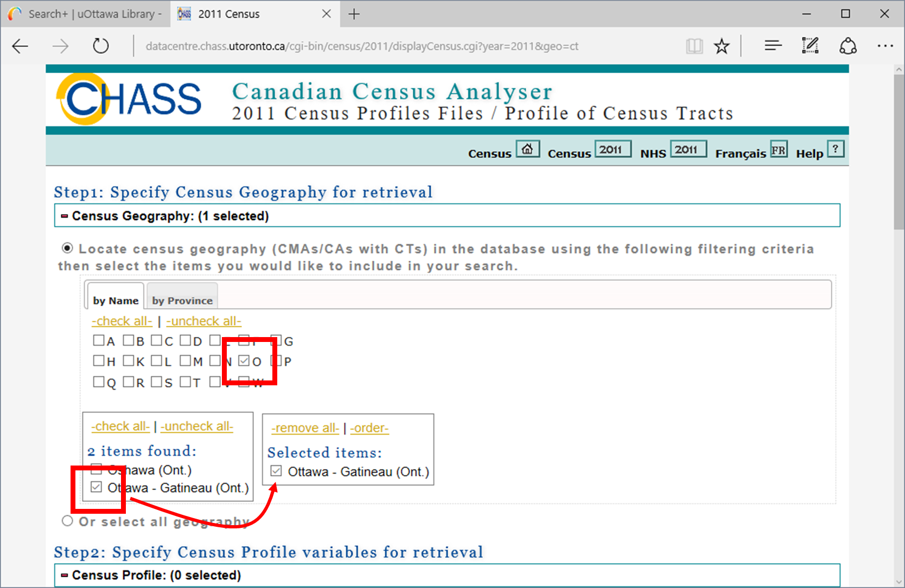

1. Now, under “Step2: Specify Census Profile variables for retrieval”, place a check mark in each of Population, 2011 (v1) and Population, 2006 (v2) to specify that you want to download those two census variables:

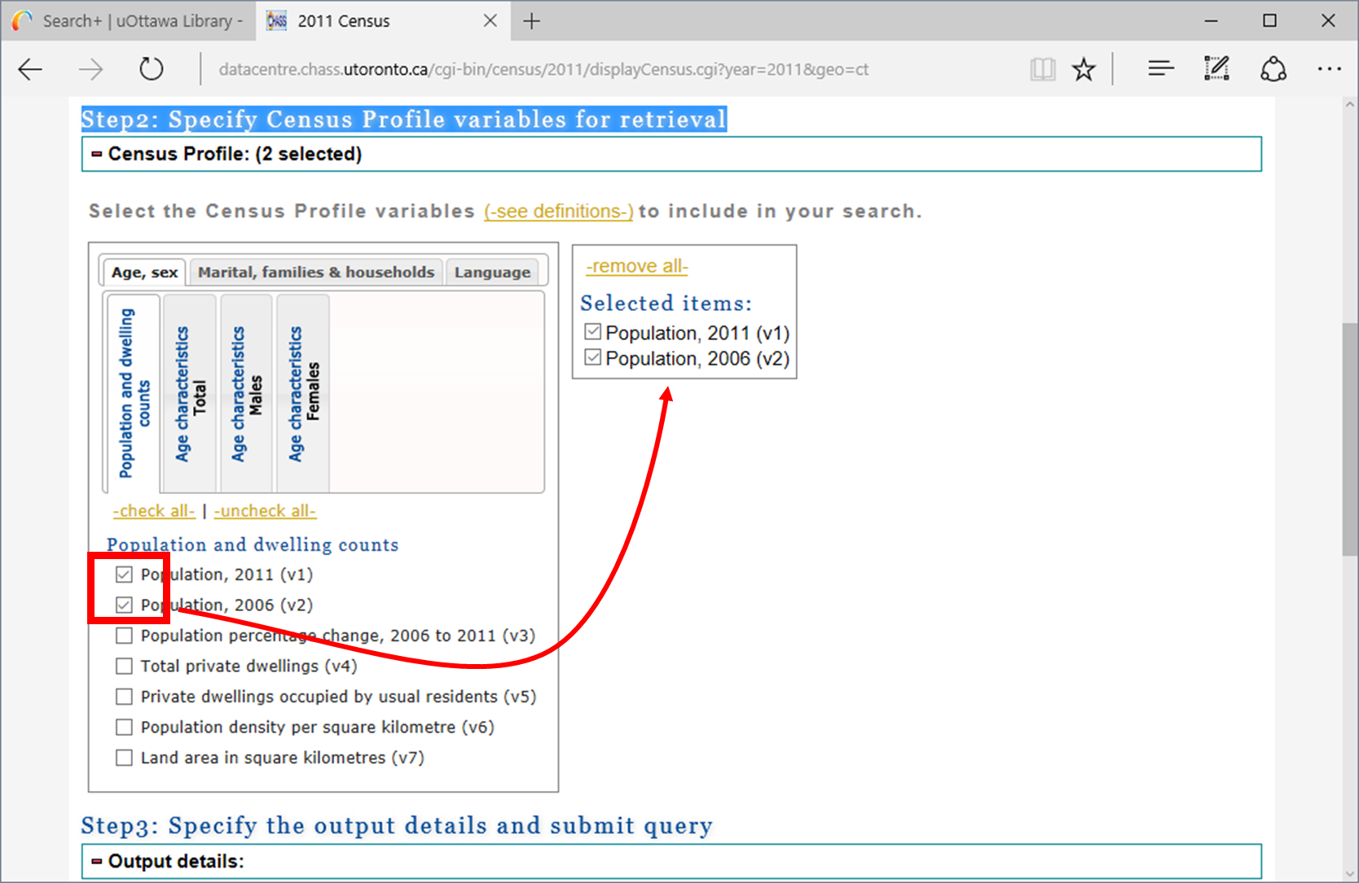

1. Next, you need to know what you are downloading, i.e., what do these variables mean, and how are they defined. So click on the (-see definitions-) link:

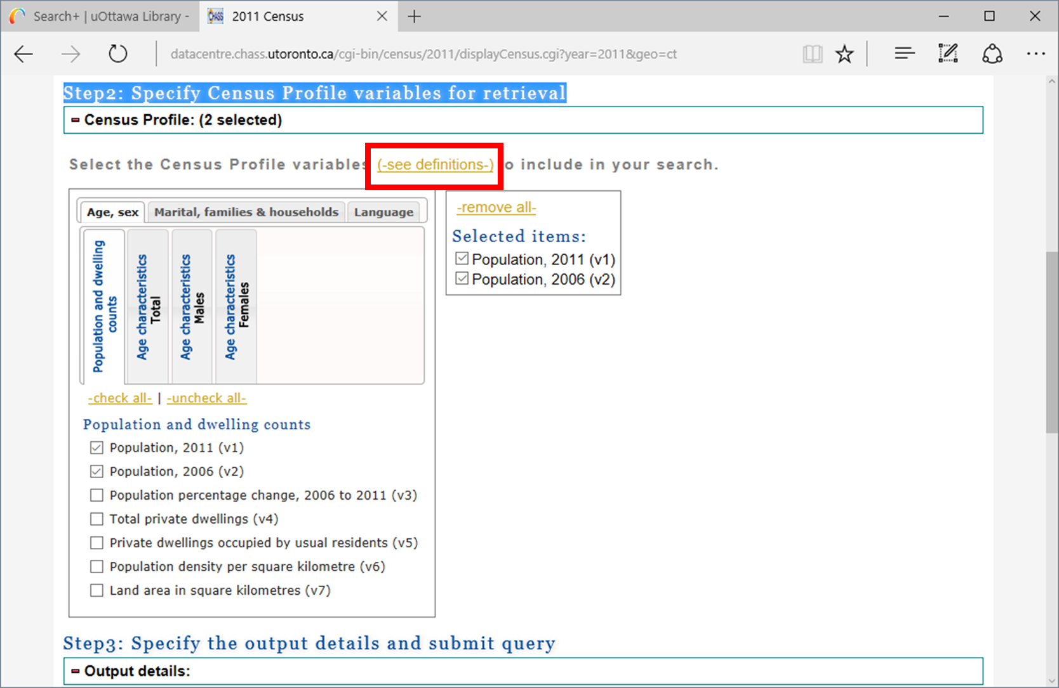

1. Read the information about the 2011 and 2006 population:

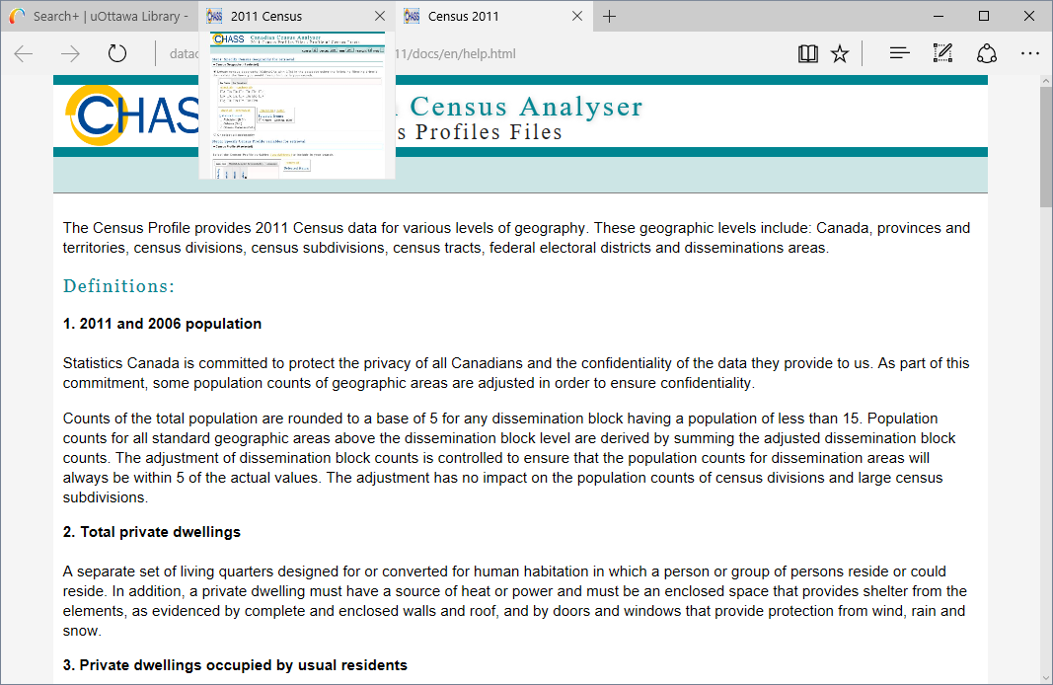

1. Return to the 2011 Census tab in your browser. Under “Step3: Specify the output details and submit query”, under “Select output format”, choose “Comma-Separated Values (CSV) for spreadsheet” and click the Submit Query button:

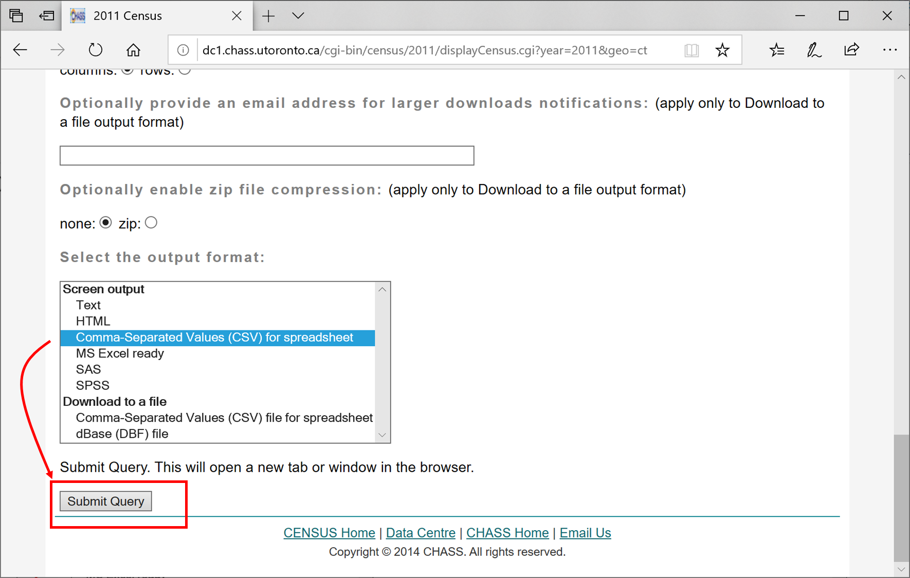

1. You will now see a webpage with the data that looks like this:

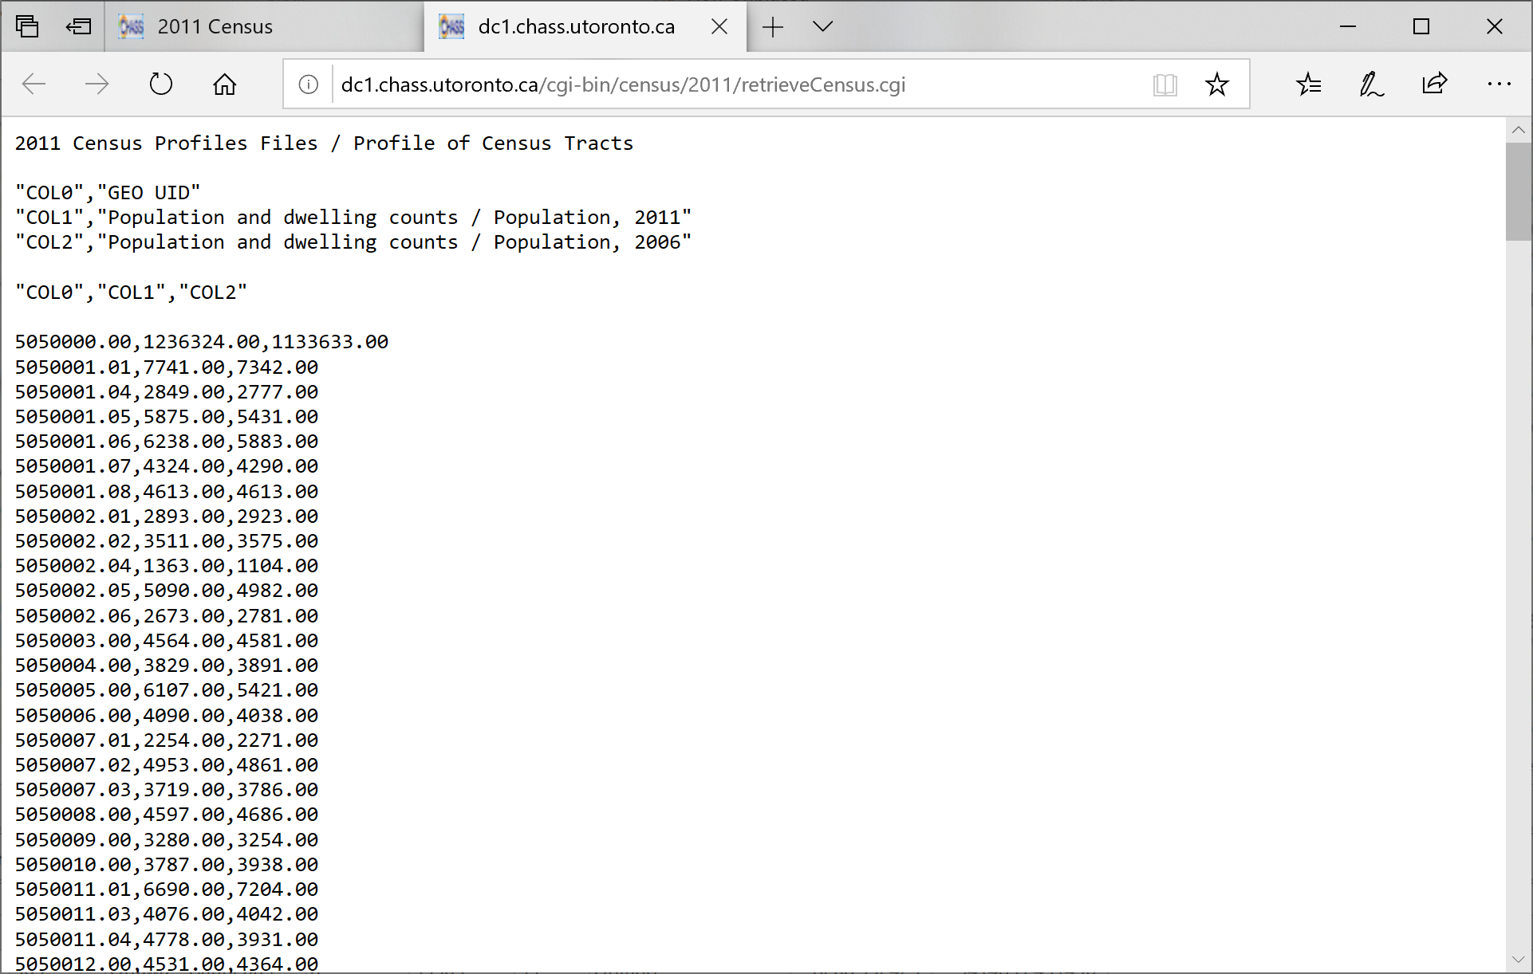

1. Select all the text on the webpage by using the key sequence Ctrl+A on the keyboard, followed by Ctrl+C to copy the data to the clipboard:

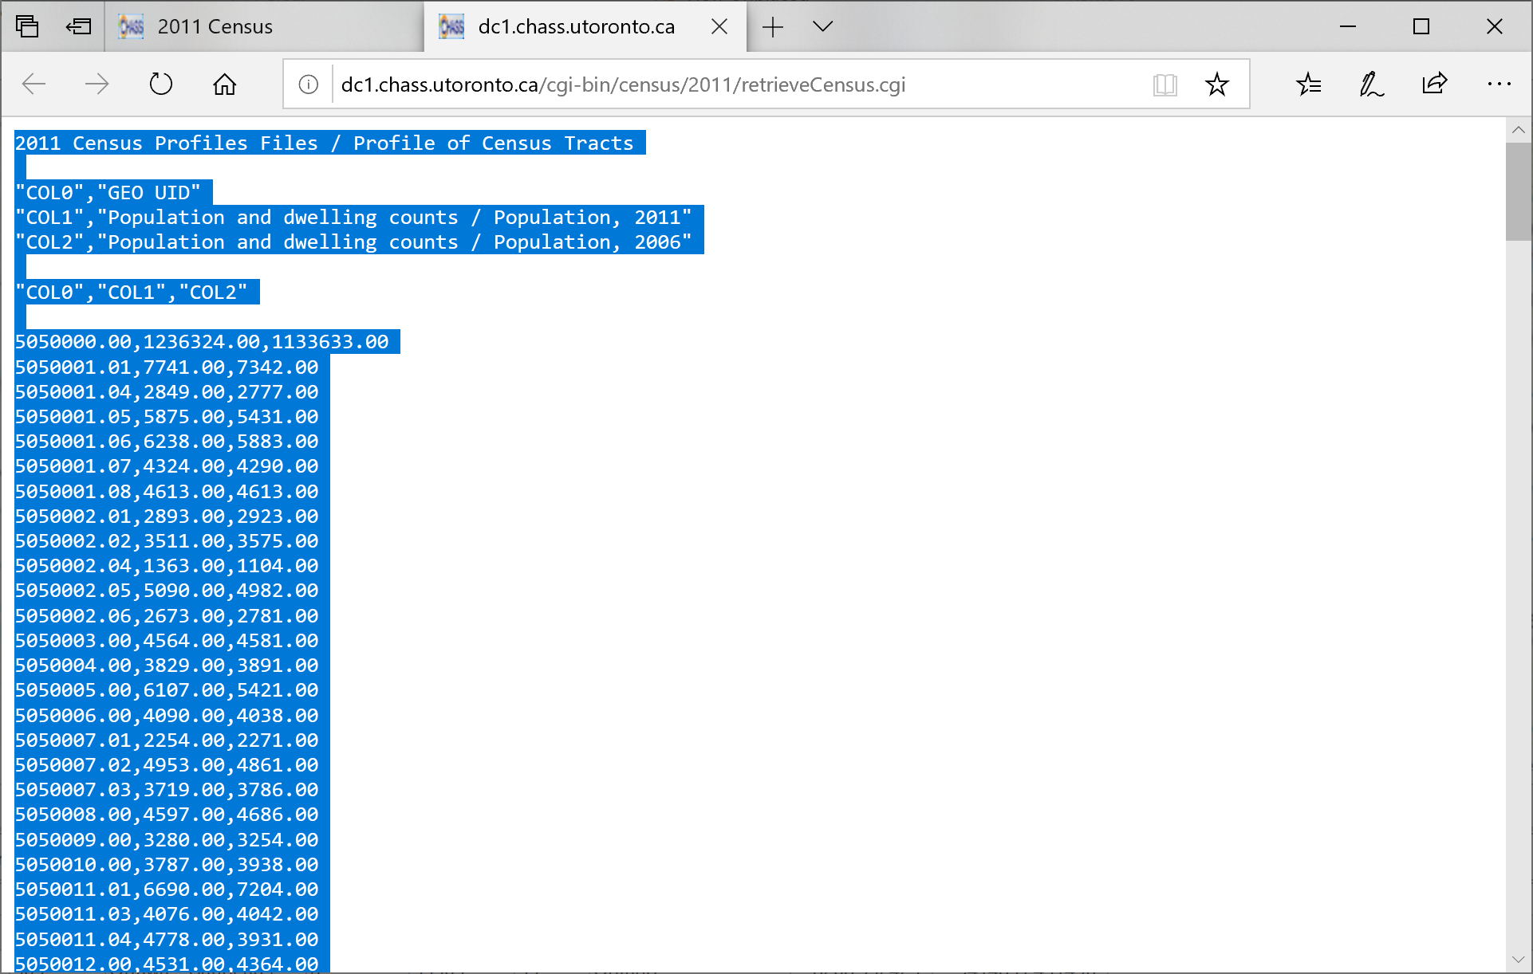

1. Open Notepad on your desktop and then use the key sequence Ctrl+V to paste the data into notepad:

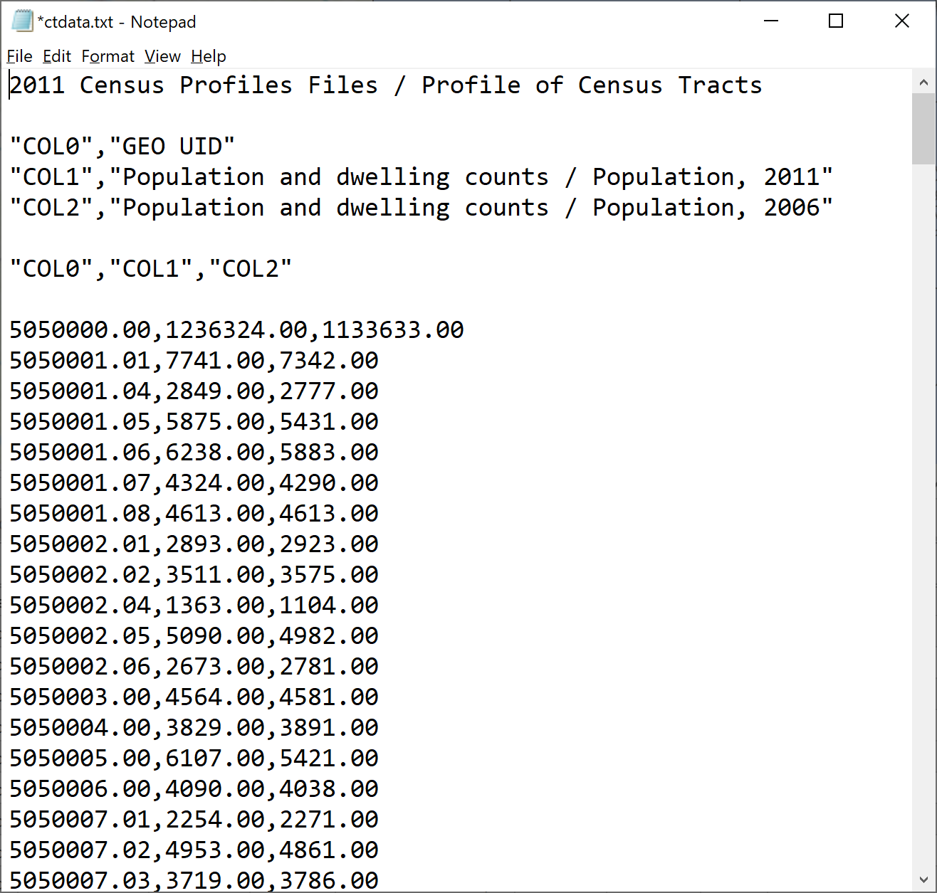

1. Now you need to edit the data so that it can be opened as a “.csv” file in ArcGIS Pro. To do so, make your data look like the following below. It is important that there are no blank lines between the header (the first row that has the column labels) and the data. Then save the file with the name “ctdata.csv”. Use the Windows Explorer to check that you did not accidentally use another file extension for the file (it can easily end up as ctdata.csv.txt, which will not work!)

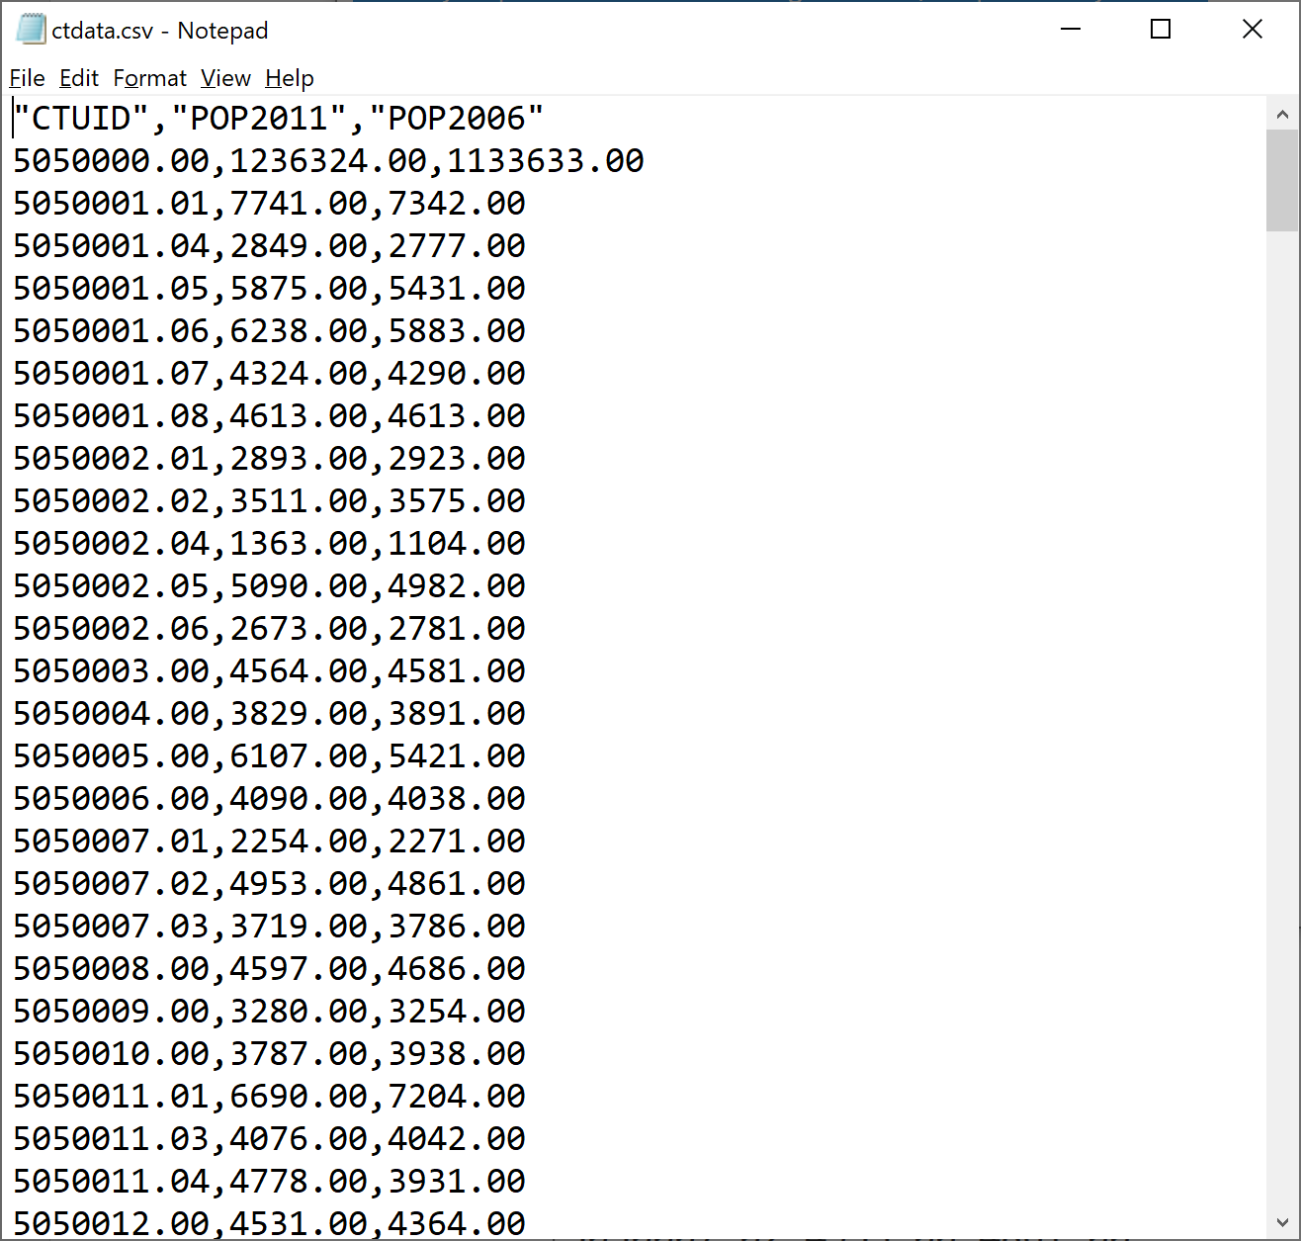

1. Now return to ArcGIS Pro. Add the folder where you saved the ‘.csv’ file, and add the .csv file to the project contents:

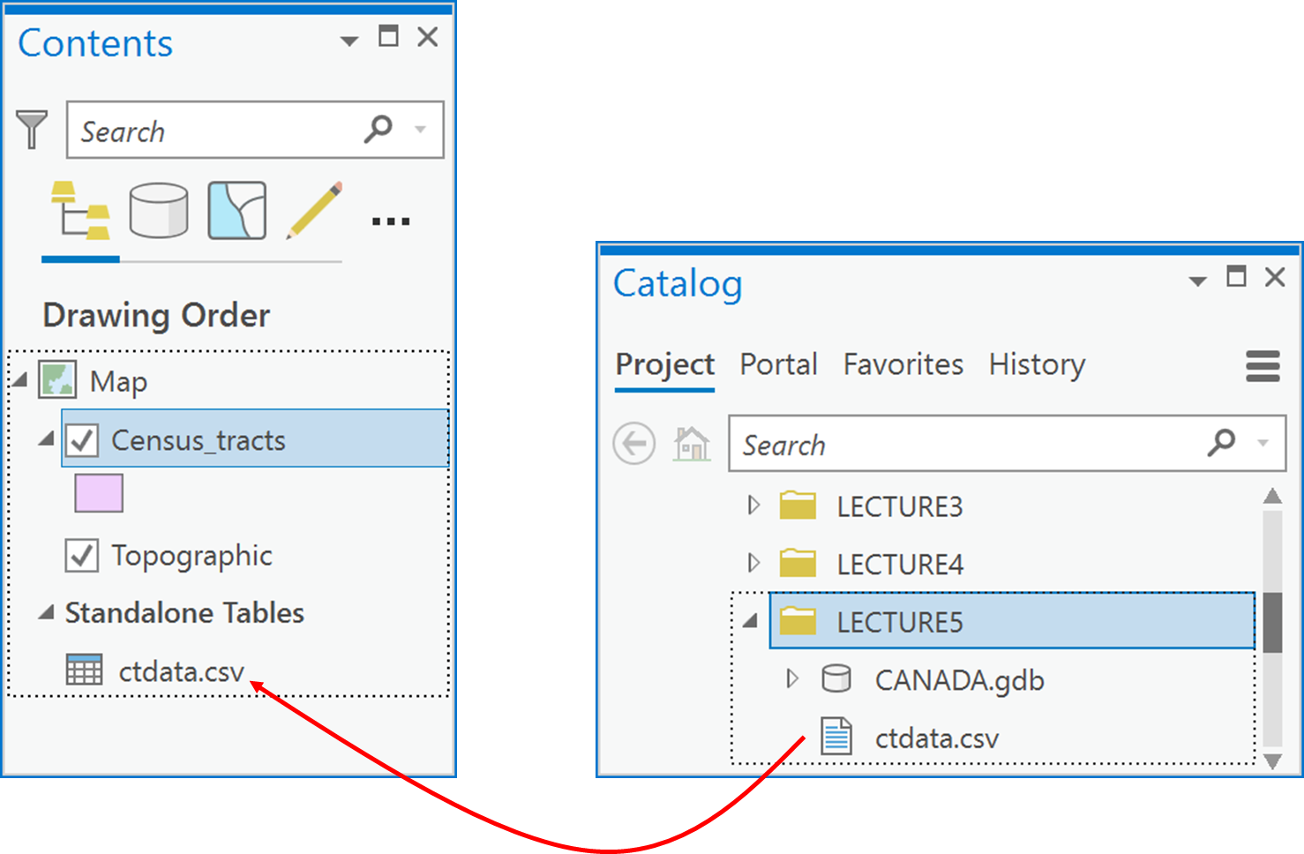

1. Open and examine this stand-alone attribute table and examine the table of the Census_tracts feature class that you downloaded, renamed and added to ArcGIS Pro in Q1 above. You will see that both have a CTUID field but that the field values are in different formats (see the figure below). Specifically, the ctdata.csv file has interpreted the CTUID as a numeric field, whereas the Census_tracts interprets the CTUID field as text. Fields can only be joined if they a) are both either text or integer data types, and b) if they contain common values that are identical for the same features. In this case, the format for a CTUID must be a text value of the form “#######.##” without exception, like ‘5050151.08’. The confusion arises because these text fields use numbers, but the numbers have no numeric meaning, they are just unique labels for each census tract. Therefore, we will need to do some data manipulation on the ctdata.csv file before we can get access to the population fields for mapping or further analysis.

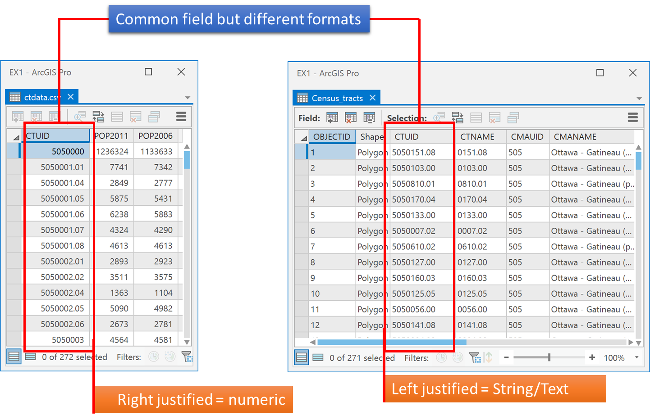

1. Open the Table to Table tool, and select your ctdata.csv file as “Input Rows”, and the data.gdb geodatabase from Q1 as the “Output Location”. Call the Output Name ‘population’ as the new table. Then click Run.

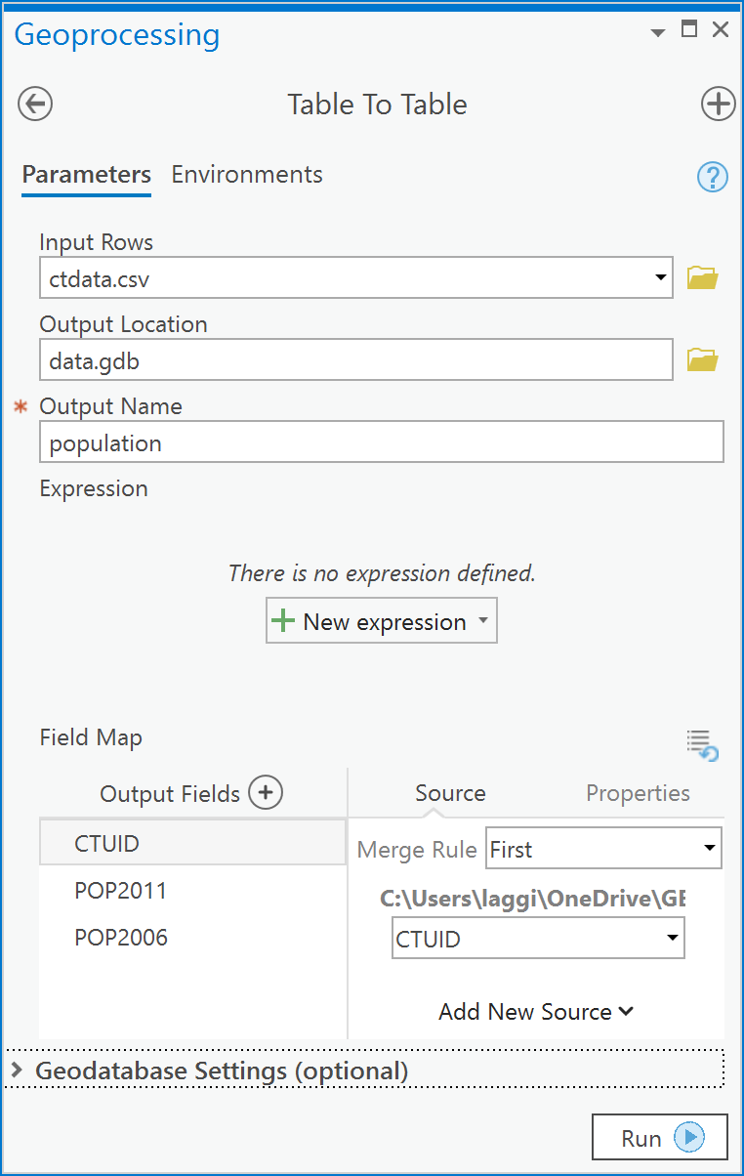

1. You should now have a population table in your data.gdb.

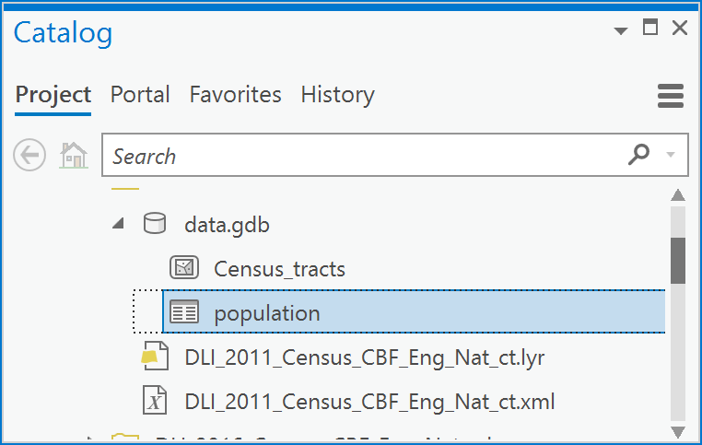

1. Open the population table and you will see that there is a new attribute added called OBJECTID. That is automatically added to any table within a geodatabase. You will notice that the first row has very large populations; that is because it is the total population for each year. You can delete that row or leave it, it will not affect the rest of this exercise. More importantly, you will also notice that the CTUID is still in numeric format and many of the values are missing the “.##” (such as “.00”) parts of the CTUIDs:

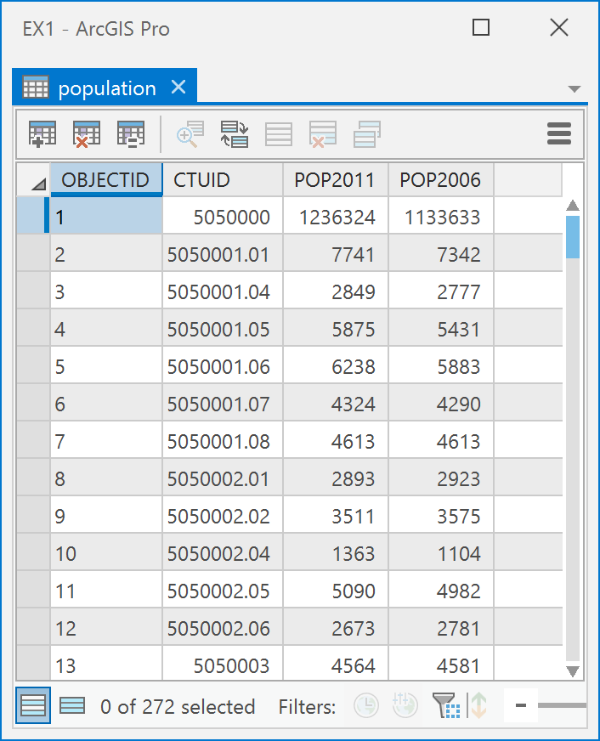

1. Add a new field (Data Management Tools -> Fields -> Add Field) to the ‘population’ table called CTUID2. Make it of type “Text” and a field length of 10 (digits). Run it.

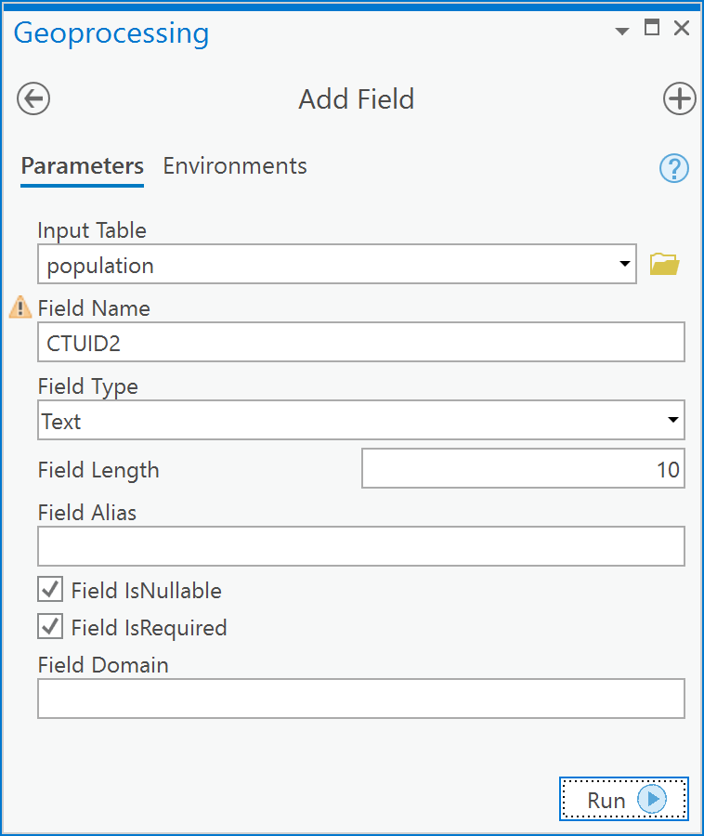

1. Now, in the population table you should see a CTUID2 field. Right click on the field and choose Calculate field:

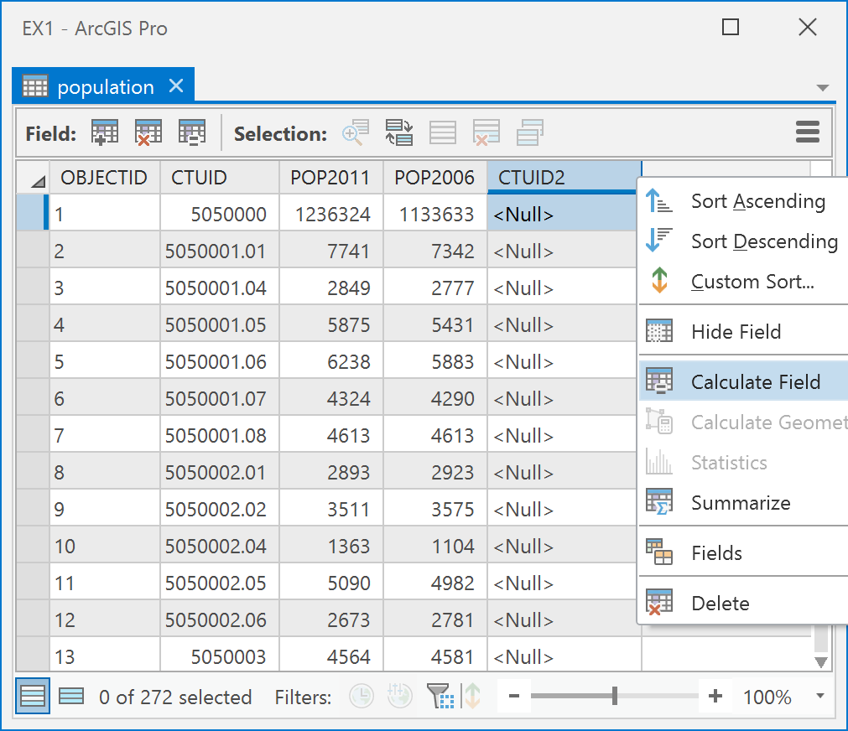

1. In the Calculate Field tool, type, under CTUID =, this statement:

"{:.2f}".format(!CTUID!)

1. Then click Run

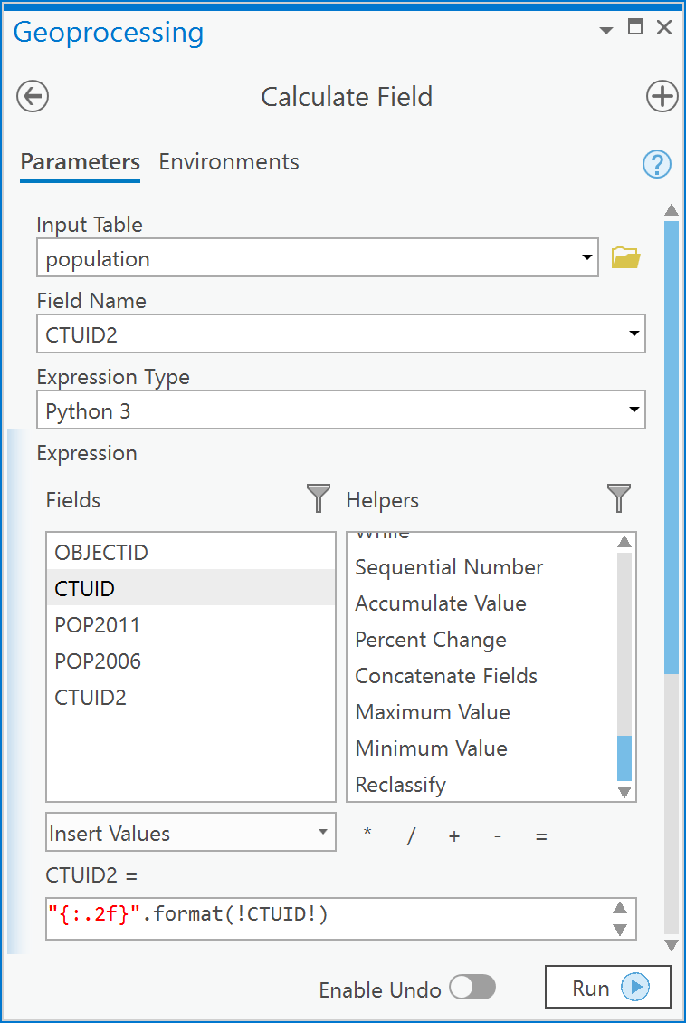

1. You will now see your population table has the correctly formatted CTUIDs in the CTUID2 field and the values are left justified – a visual indicator that this is a text field.

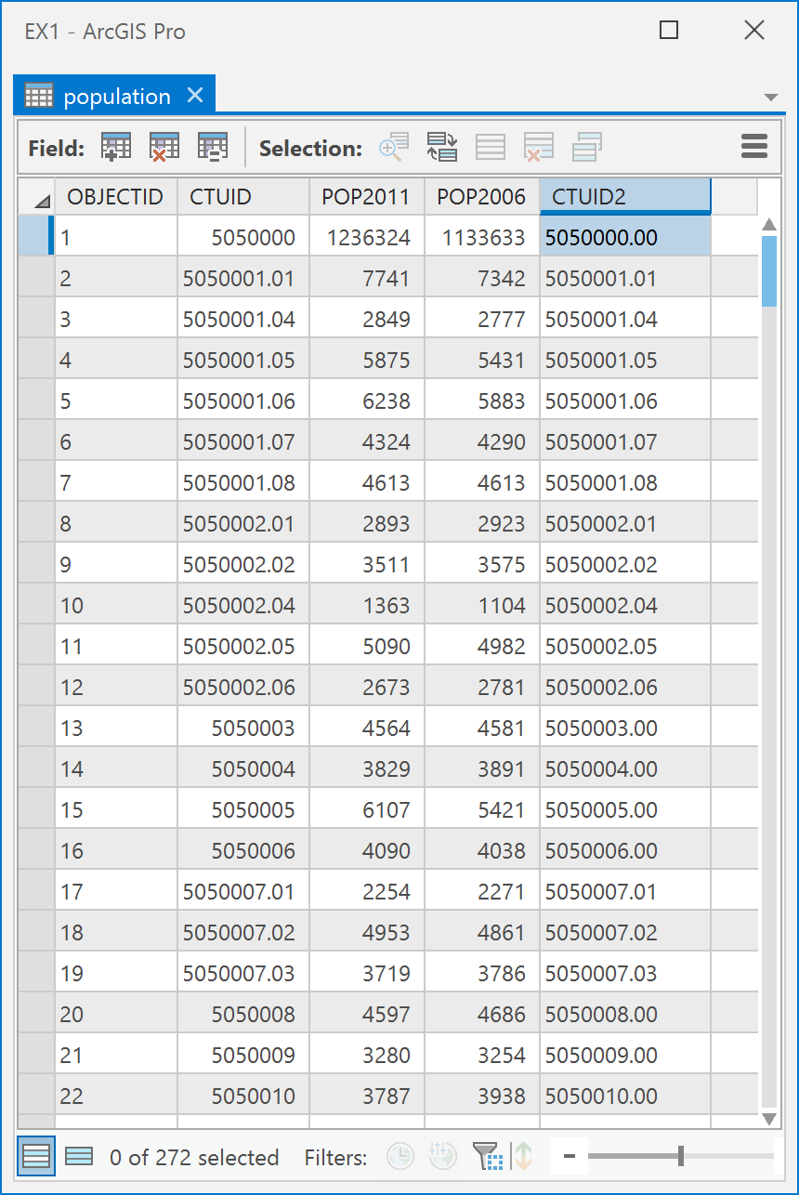

Q3: How can I relate the geospatial data layer Census_tracts to the attribute data table with the population information?

One way to access the fields in the population table from your census tracts layer is to tell ArcGIS how to match the CTUID field values in the census tract layer to the CTUID values in the population table. You can do this by creating a 1-to-1 ***relationship class*** within the geodatabase and then use that as a basis for querying and selecting census data in the population table to the Census_tracts attribute table.

1. In ArcCatalog, right-click on the **data.gdb** geodatabase and choose New -> Relationship Class:

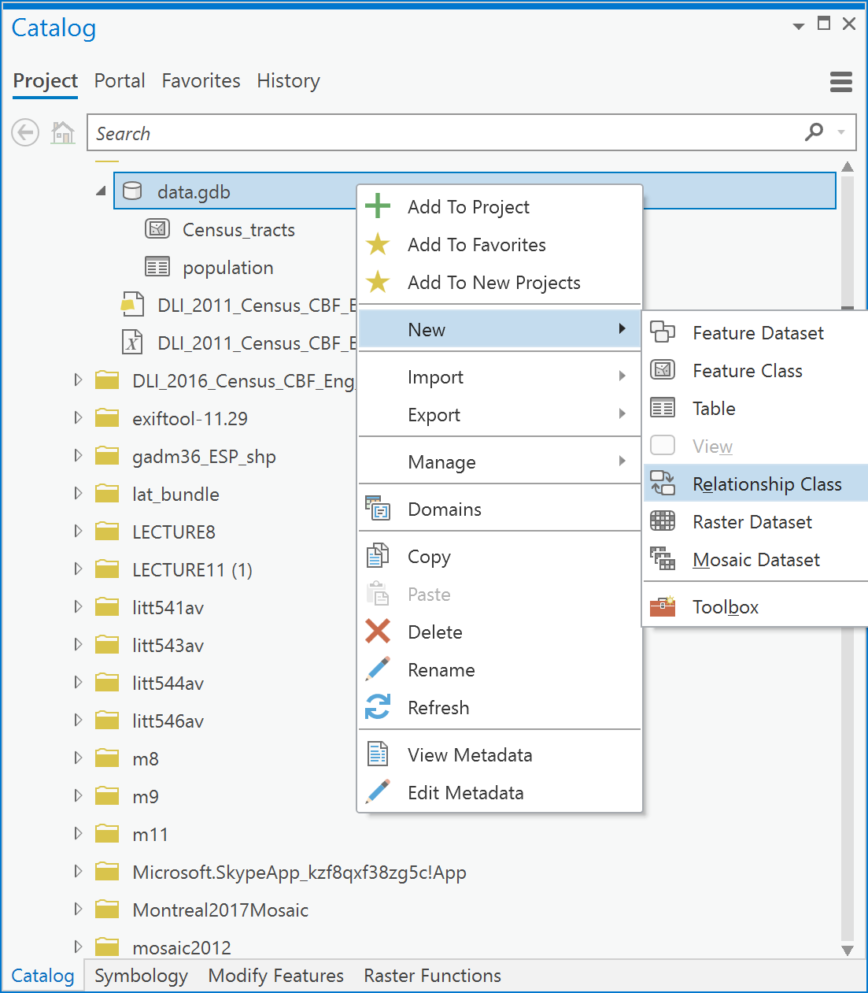

1. Set the following in the Create Relationship Class dialog box:

* ***Origin Table***: Choose Census_tracts.
* ***Destination Table***: Choose population. You have now specified that the Census_tracts table contains the source records for this relationship and that those records are related to the population table.
* ***Output Relationship Class***: this is the name in the geodatabase that this relationship will be visible as, call it pop.
* ***Relationship Type***: Simple.
* ***Forward path label***: type in ‘population’, which specifies the label when navigating from the origin class (Census_tracts) to the destination class (population). So we call this population to remind us that the relationship goes from Census_tracts to population.
* ***Backward path label***: type ‘Census tracts’.
* ***Message Direction***: choose ‘None (no messages propagated)’, since this relationship class won’t be used for editing features. If it was used in editing, then deleting a feature in one feature class would send a message to the other and tell it that there was a deletion. Such operations are critical and are part of what is called referential integrity: search for ‘referential integrity’ in the ArcGIS Pro help file to understand this type of relationship.
* ***Cardinality***: this specifies the type of relation, in our case, each census tract can have at most one record in the population attribute table, so we choose a ‘One to one (1:1)’ relation.
* ***Relationship class is attributed***: We do not need any new attributes to be stored for this relation so leave the “Relationship class is attributed” check box blank.
* ***Origin Primary Key***: specify the common field that contains a unique identifier for each spatial unit within the Census_tracts layer (origin), in this case, it is the CTUID field.
* ***Origin Foreign Key***: specify the common field in the population table, so select CTUID2 in the dropdown.

1. Click Run.

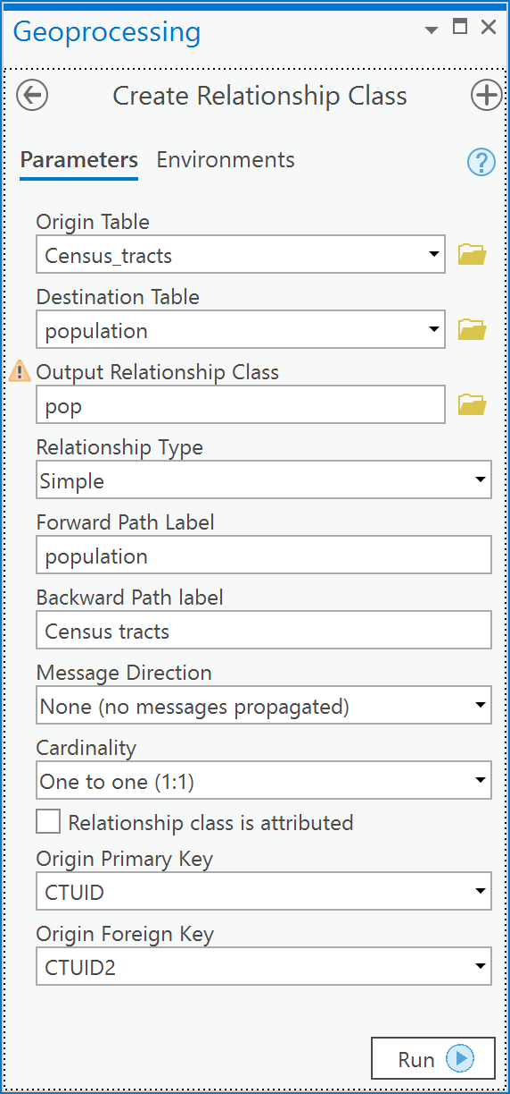

1. Now examine the data.gdb geodatabase and you should see a relationship class item added called ‘pop’:

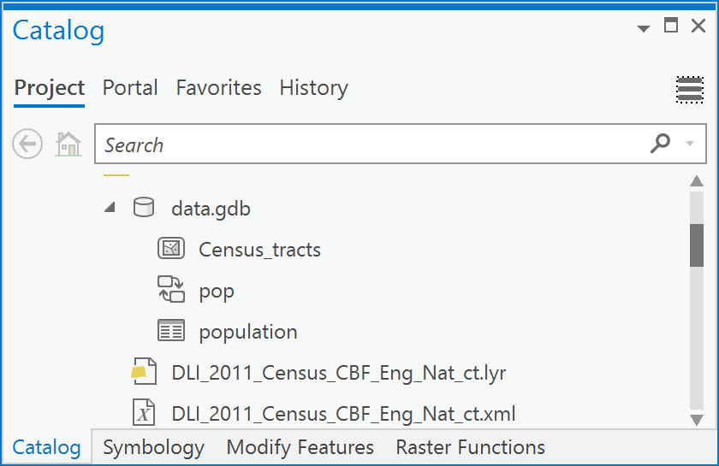

Q4: What can I do now that I have established a relationship class between my census population table and my census tracts feature class?

The relationship class is like a table join, but you do not see the records from the related table (population) within the Census_tracts table. There are limitations to what can be done with relationship classes. For example, you can query using related tables in SQL, but you cannot use fields in tables participating in a relationship class for field calculations in the origin table. Let’s see what we can do:

1. Arrange the Census_tracts and population tables side by side. In the menu, choose “Select related records” in both tables:

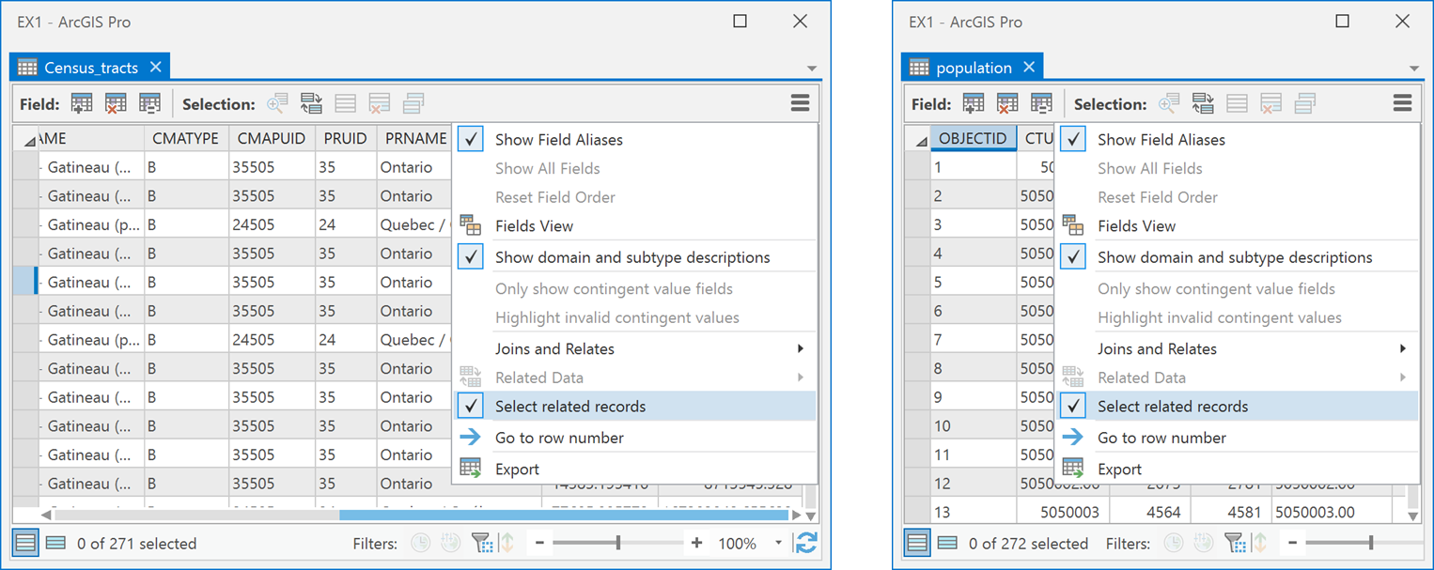

1. Next, select a few records in the Census_tracts table and examine the population table. You will see that corresponding records are selected in the population table!

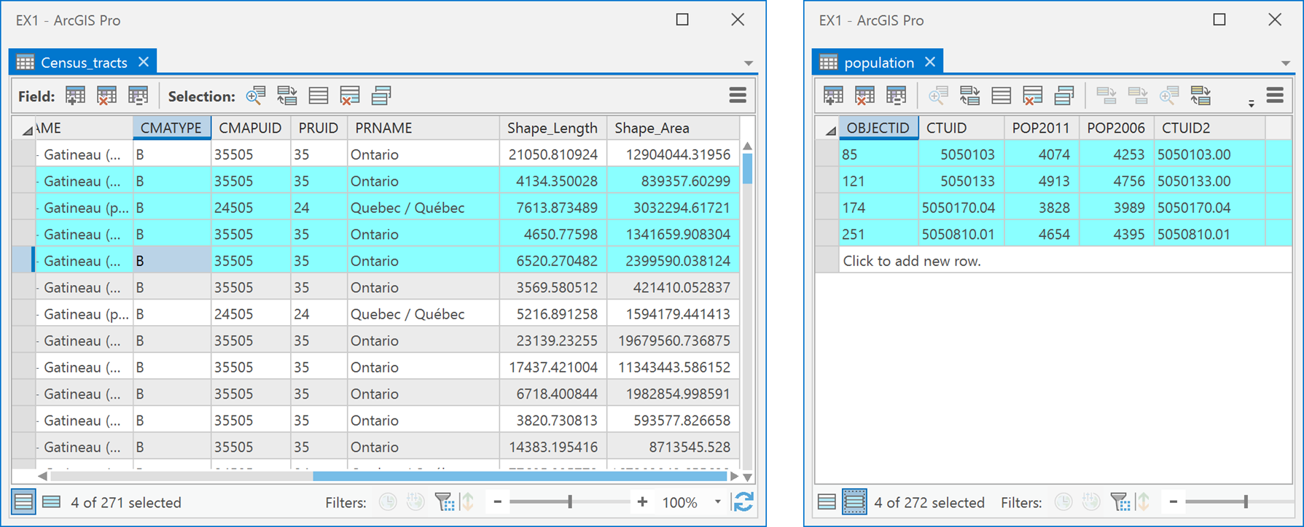

1. To have effect in the other direction, select some records in the population table and then from the menu choose Related Data -> Census_tracts – Census tracts. You will now see that those features will be selected in the Census_tracts table and on the Map:

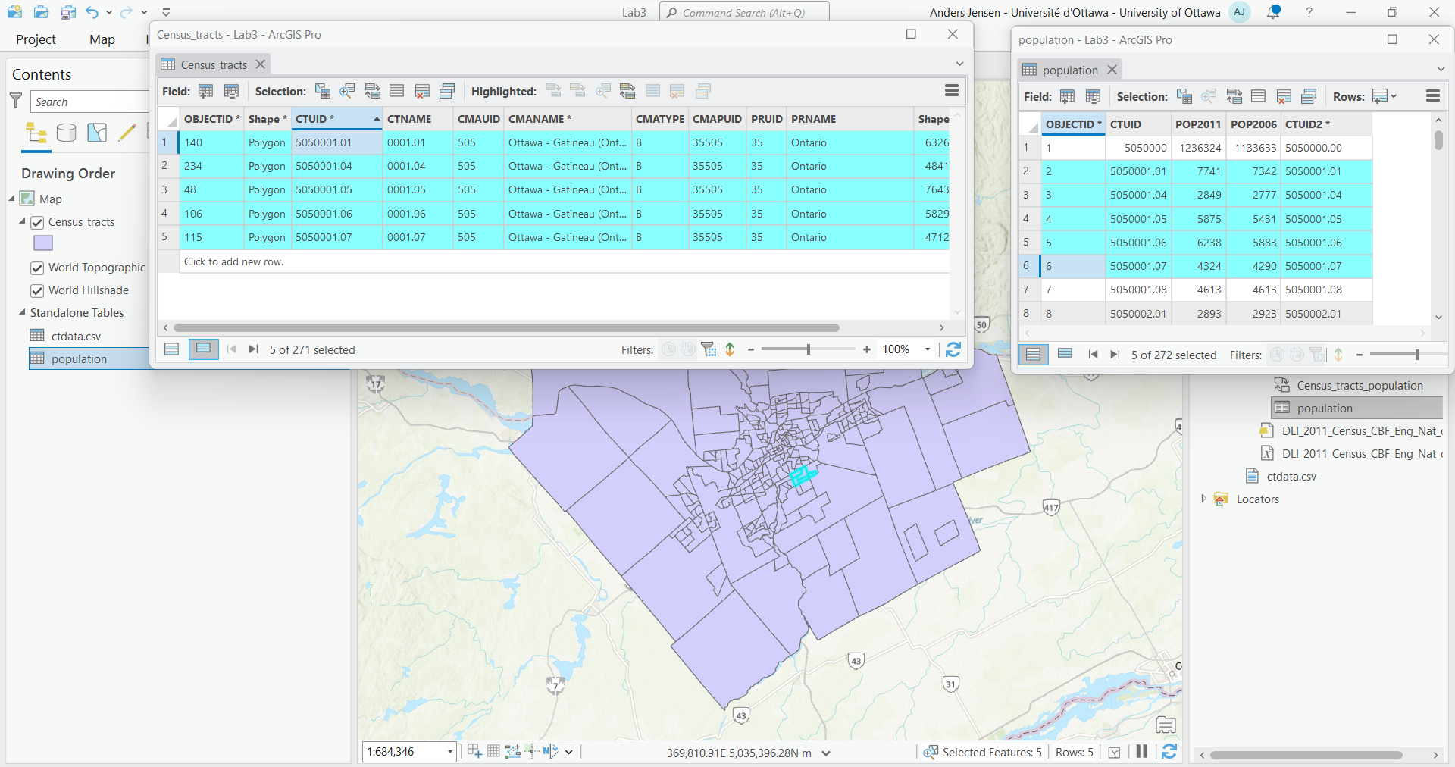

1. The relationship class adds this link between the two attribute tables that have the common values in the CTUID and CTUID2 fields. So you can query the Census_tracts table using SQL statements such as this:   
     
   CTUID IN (SELECT CTUID2 FROM population WHERE POP2011 > **7000**)

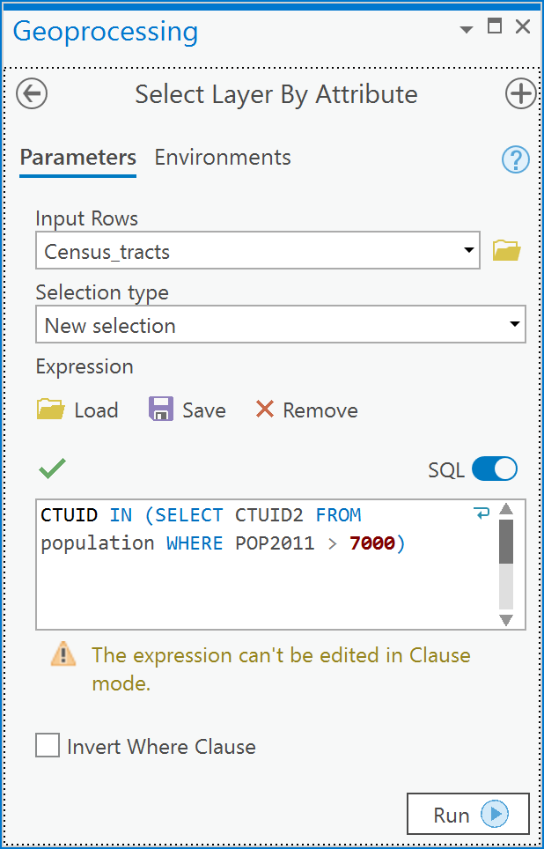

You will see all census tracts selected whose population is greater than 7000 people.

*Note: One caveat of using census data that is reported within polygon areas like census tracts is that there is an implicit assumption that the number of things, like people, are uniformly distributed across the area of each tract. In reality, that is not true because people can’t live everywhere within a census tract, e.g., people don’t live in forests, or on streets etc., because people live in houses. Dasymetric mapping deals with increasing accuracy of maps by only showing data where people can live rather than everywhere. We deal with this in a more advanced course.*

1. You could also use more complex SQL statements that evaluate arithmetic expressions on the related table’s fields. Perhaps you want to select all census tracts that have had a decrease in the population from 2006 to 2011:  
     
   CTUID IN (SELECT CTUID2 FROM population WHERE (POP2011 - POP2006) < **0**)

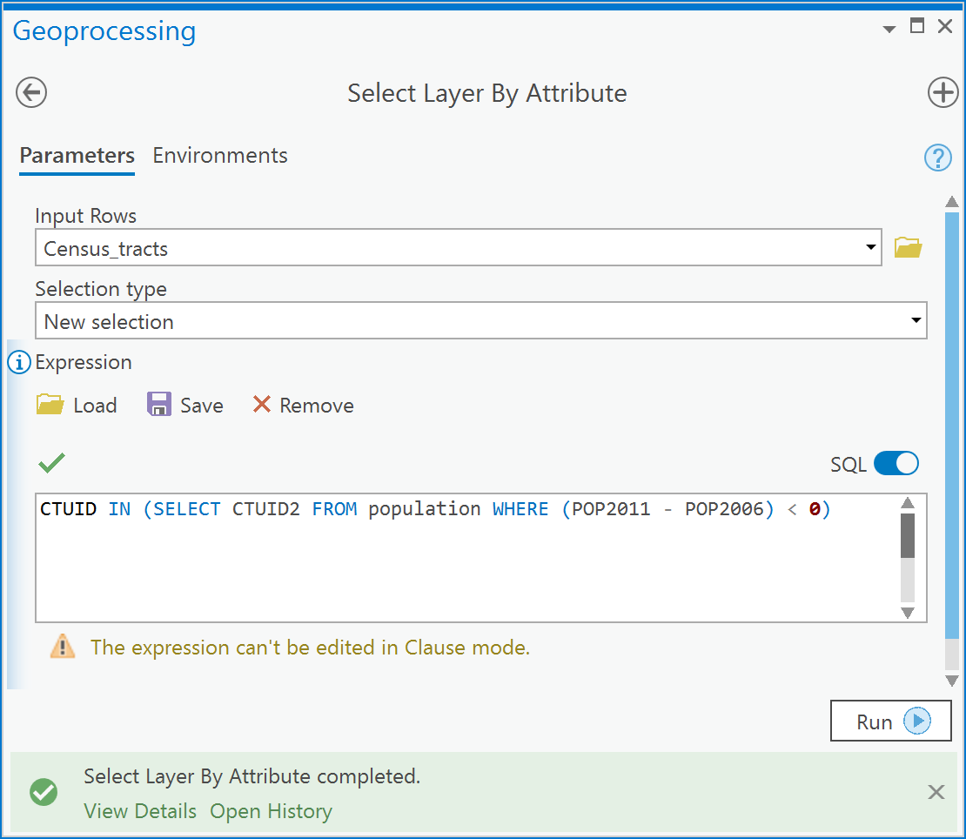

Q5: How can I map the population within Census tracts using my population table?

Relationship classes are limited when it comes to symbolizing fields in related tables. So we can’t map the population within the Census_tracts layer using relationship classes. Therefore, we need to rely on table joins to append the population table’s attributes to the Census_tracts layer. You can quickly do an **ad-hoc join** of the population table to the census tract layer so that you can have direct access to the POP2011 and POP2006 fields, so that they are visible in the Census_tracts layer as if they were part of the census tract layer’s attribute table - but be aware that this is only a virtual join when we use the Add Join tool.

1. Right-click on the census tract layer in the Contents and choose Joins and Relates -> Add Join:

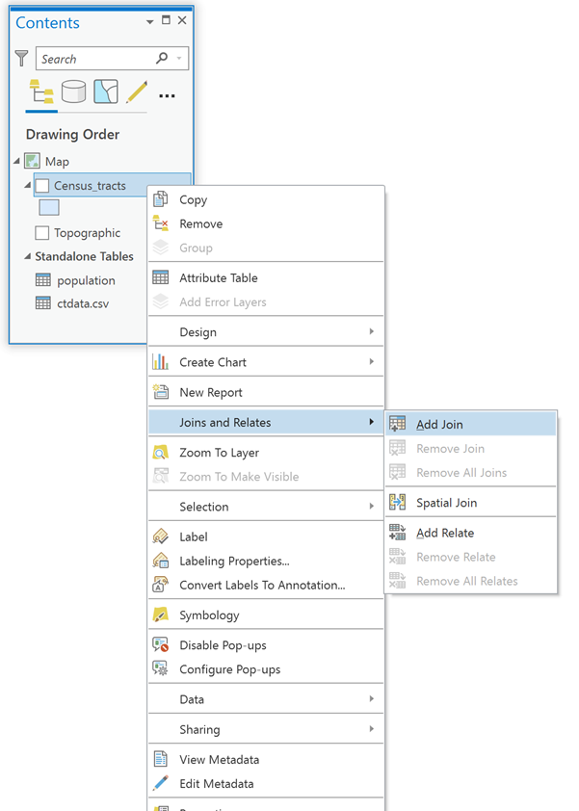

1. In the Joins & Relates dialog box, under ‘Layer Name or Table View’, specify Census_tracts. Under ‘Input Join Field’ choose CTUID. Under ‘Join Table’ choose population and finally under ‘Output Join Field’ choose CTUID2. Click OK.

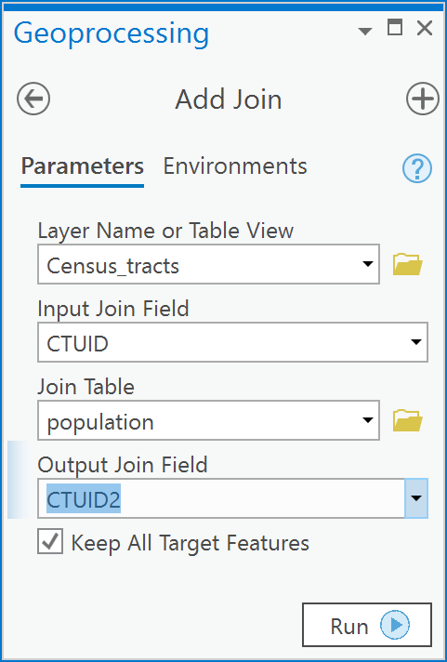

1. Open the Census_tracts attribute table, scroll to the right, and you should see the POP2011 and POP2006 fields appended to the end of the attribute table’s list of fields:

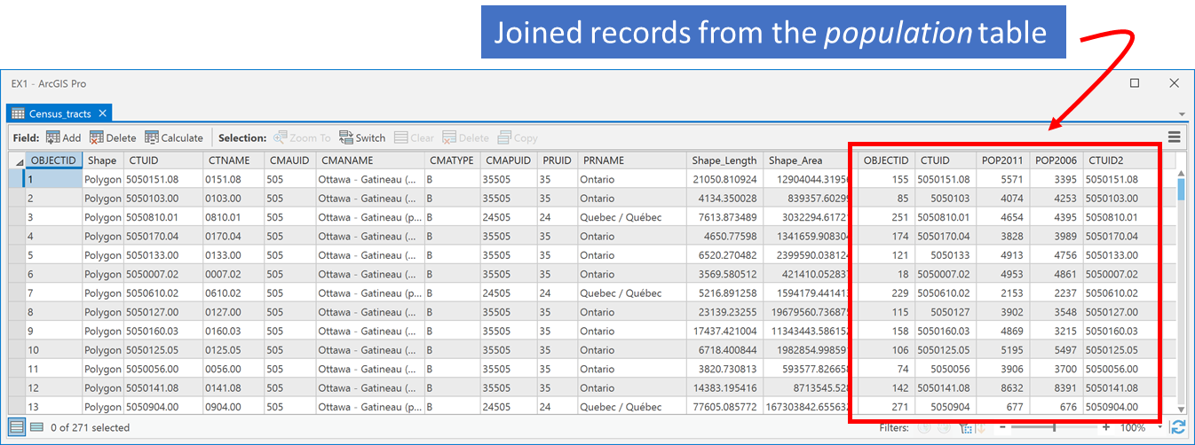

1. You can now Query, Map or Calculate Fields using these appended records within the Census_tracts attribute table. For example, using the **Select by Attributes** tool on the Map tab to open the “Select Layer by Attribute” tool and, for example, show which census tracts have a population decrease between 2011 and 2006 (note this is just a different way of doing what we did in Q5). You could query for:

population.POP2011 < population.POP2006

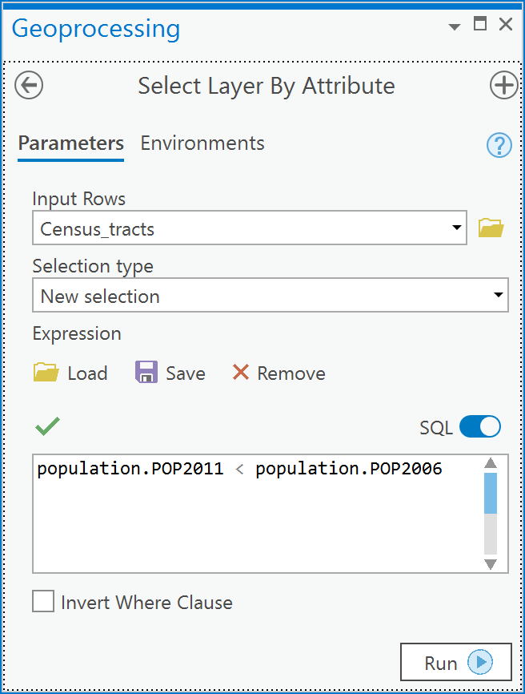

1. You will now see the selection made within the census tracts’ attribute table and the map.

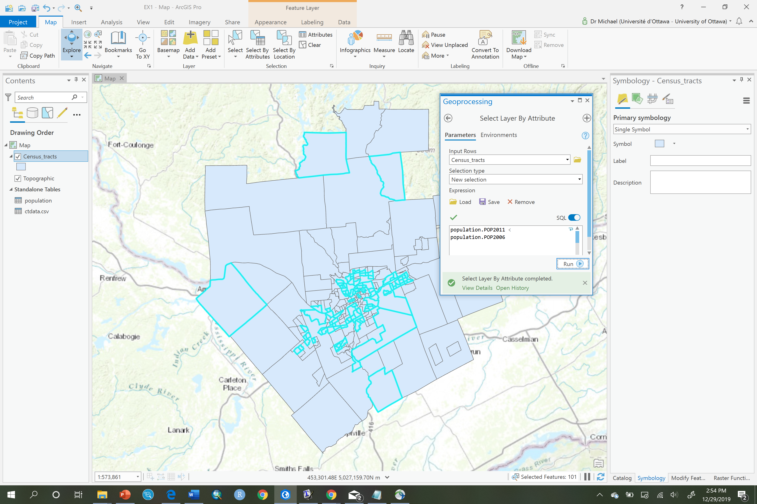

Q6: I want to calculate population density; how do I do that?

To calculate values using existing fields you will add a new field to your attribute table. For example, if I want to calculate population density in 2011 in each census tract, I would add a field of type Double (because density is a ratio and ratios will likely be real numbers) to the attribute table and then proceed to calculate the population density as number of persons per square kilometer,

1. Go to Data Management Tools -> Field-> Add Field,

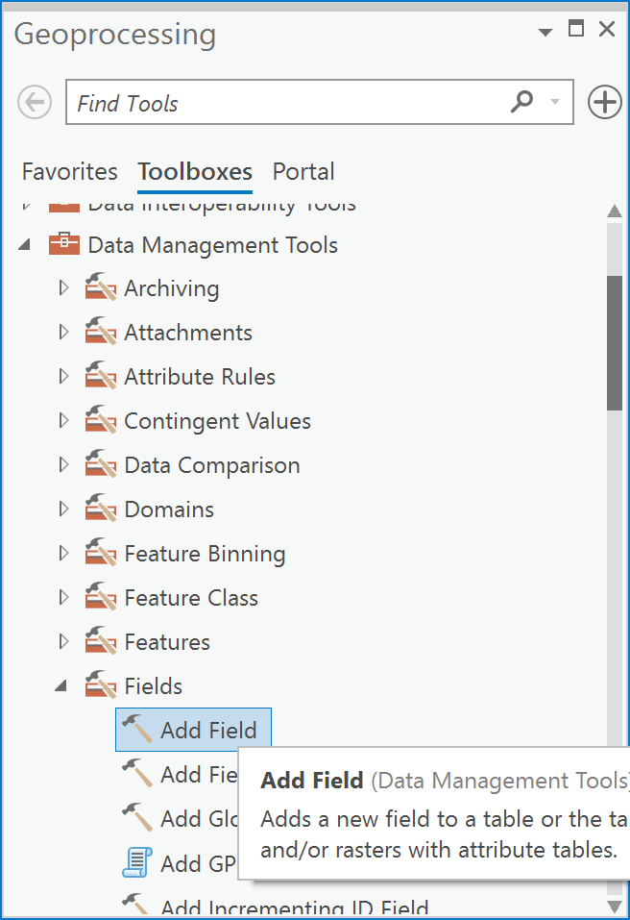

1. In the Add Field dialog box, choose your census tracts layer in the ‘Input Table’ dropdown, then under ‘Field Name’ type ‘POPULATION DENSITY 2011’ and choose ‘Field Type’ as Float or Double, and click Run:

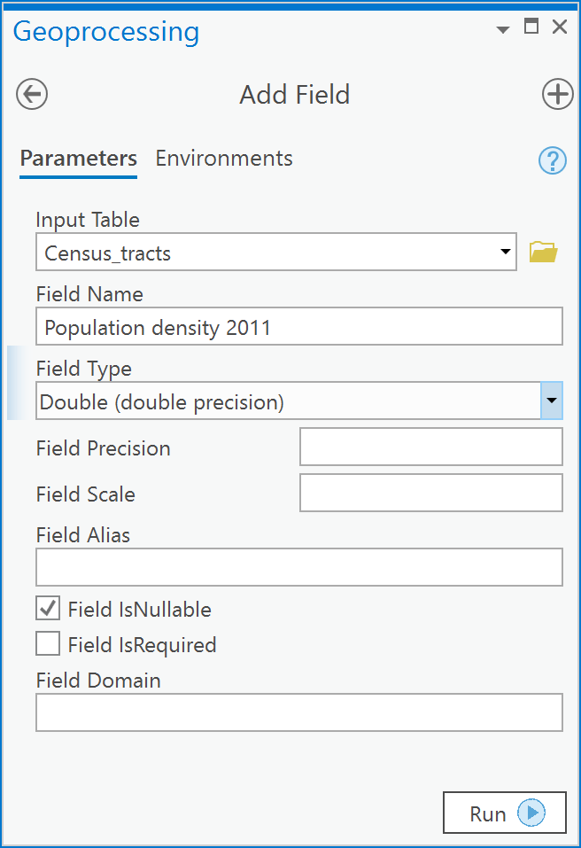

1. Examine your census tracts attribute table, you should see a new field called POPULATION_DENSITY_2011 with all <Null> values. Notice that ArcGIS replaced the spaces in the name you typed with underscore characters “_”. It did this because spaces are not allowed in database field names.

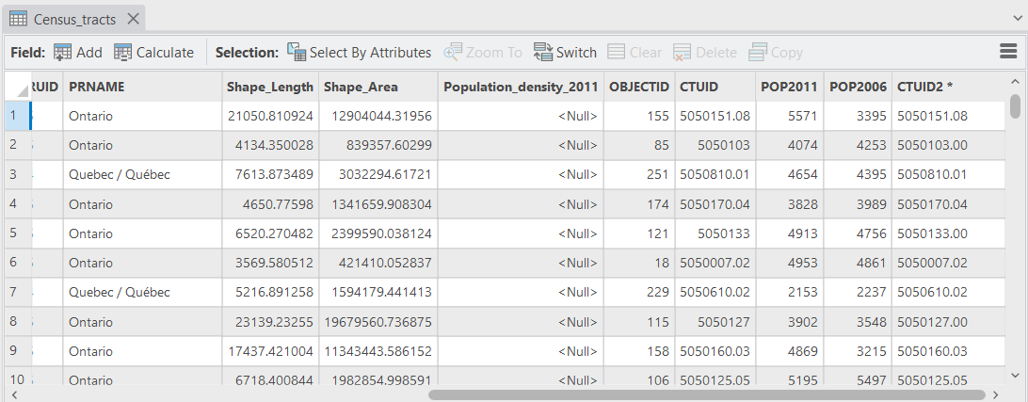

1. Next, make sure nothing is selected in your Census_tracts attribute table by clicking on the Clear button in the Selection group of the Map tab of ArcGIS Pro.
2. Next, open the Calculate Field tool in ArcToolbox under Data Management Tools -> Fields:

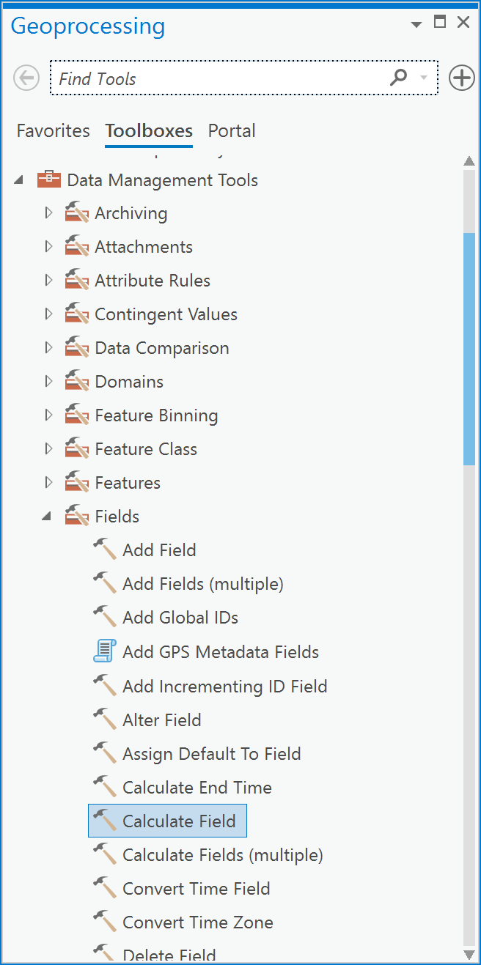

1. In the Calculate Field dialog box, (i) choose your census tracts layer under ‘Input Table’, (ii) under ‘Field Name’, choose the Population_density_2011 field, (iii) enter the expression: **!population.POP2011! / !Census_tracts.Shape_Area!**, and (iv) click Run.

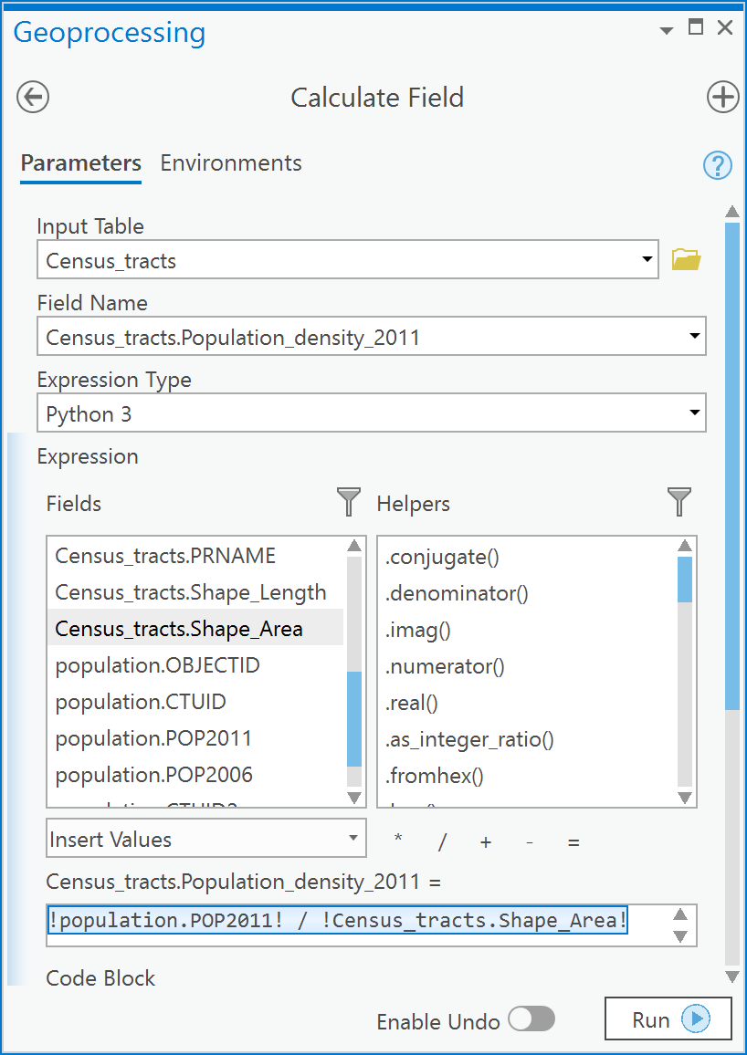

1. Open your census tracts attribute table, remove all joins, and examine the population density:

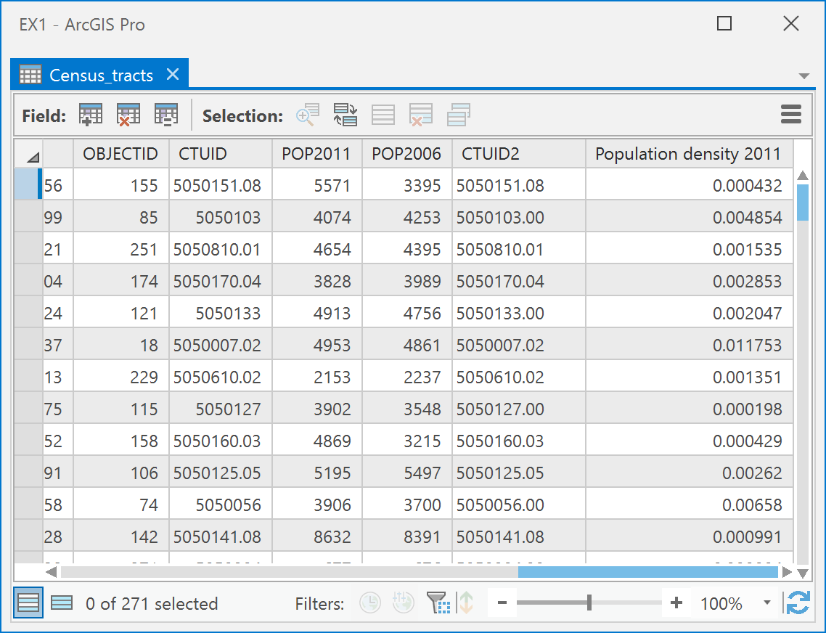

1. The population density values are in units of persons per square meter which is not a normal way to represent population density; usually you would have this in persons per square kilometer. To change this we will multiply this field by 10002 , or 1,000,000, because there are 10002 m2 in one 1 km2. In the Calculate Field dialog box, (i) choose your census tracts layer under ‘Input Table’, (ii) under ‘Field Name’, choose the Census_tracts.Population_density_2011 field, (iii) enter the expression **!Census_tracts.Population_density_2011! * 1000**2**, and (iv) click Run.

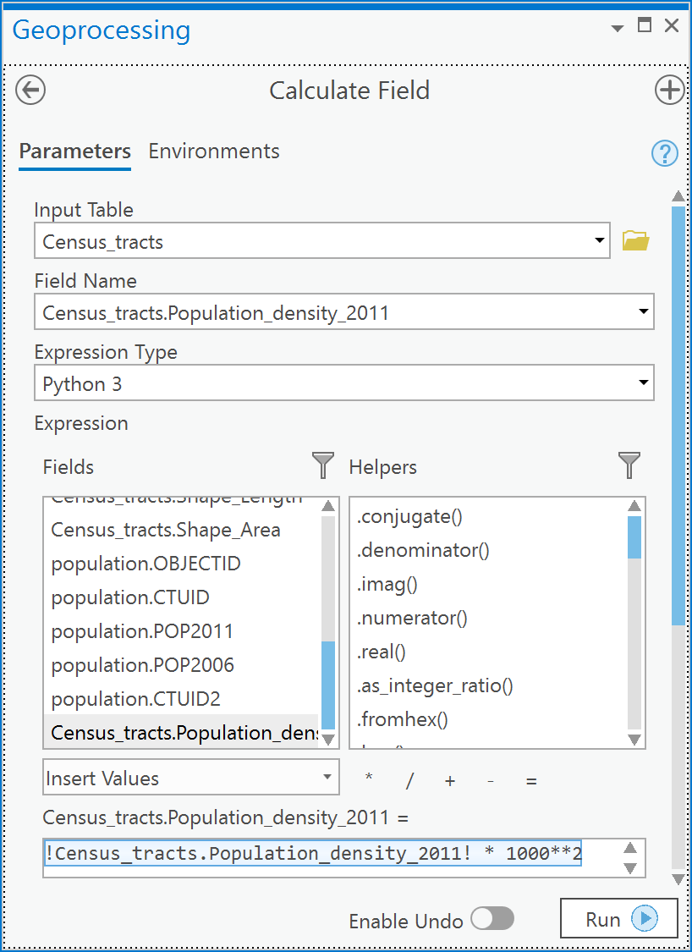

1. Now examine the census tracts attribute table and you will see that the population density values are now more reasonable (and interpretable) as persons per square kilometer:

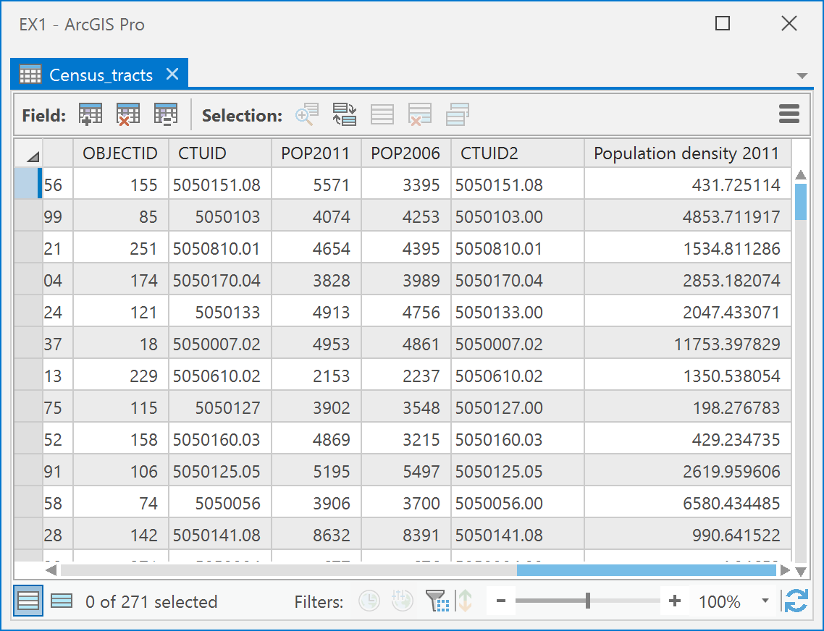

1. Now, symbolize the census tracts layer by population density using a Graduated colors map. Right-click on the Census_tracts layer in the Contents and choose Symbology. Select Graduated colors as Primary Symbology, then set the ‘Field’ as Population_Density_2011, and under ‘Method’ select a Quantile classification. The result should something like this:

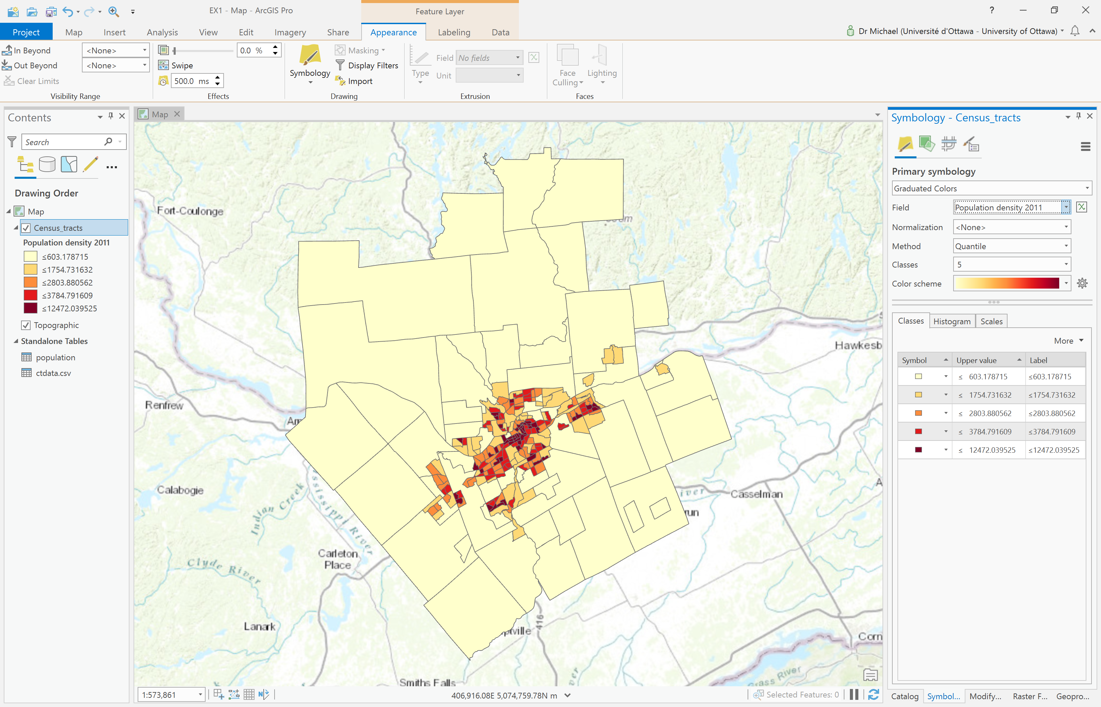

Answer the following questions.

*Note: Some of these questions require an explanation, so read carefully. Some questions also require a map as part of the answer and this must be presented correctly, so ensure that you review the ESRI Training course “Creating a Map Layout”. Marks will be deducted for incorrect presentation (also remember scale-bars should be metric).*

*Note: Some questions require you to download data from Scholars GeoPortal or the Canadian Census Analyser. If you do not have access to these resources, you can find the relevant data files in lab3.zip.*

1. [2 points] How can a relationship class enforce referential integrity in the geodatabase?
2. [2 points] In Q6, you calculated population density in the Census_tracts layer. In what coordinate system was the area for each Census tract calculated? How do you know this? Is your choice of CS a good choice for calculating area? Why or why not?
3. [1 points] Do you think that the population density map is spatially accurate as to where people are clustered? Why or why not?
4. [9 points] Download the 2016 census tracts for Ottawa-Gatineau. Next download from the 2016 tables in the Canadian Census Analyser (see Q2) the following variables for the Ottawa-Gatineau area (note that in questions 5 and 6 below you also need to download more variables, you may prefer to do all of them at once, it is up to you):

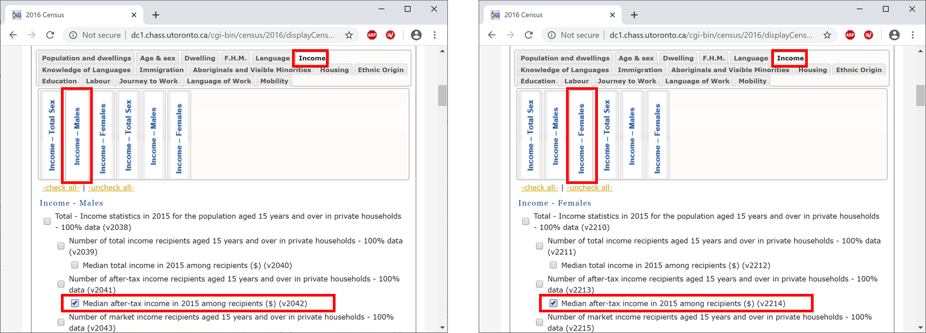

Join your data table to your census tract layer for 2016 (see Q5 for that procedure). Answer the following questions [1 point each], only the last one (i) requires a map to be created:

* 1. In *how many* census tracts do males make less than the median after-tax income of 35,000$? (you need a query to answer this so see Q5 for query examples)
  2. In *how many* census tracts do females make less than the median after-tax income of 35,000$?
  3. In *how many* census tracts do males have a greater median after-tax income than females?
  4. In *how many* census tracts do females have a greater median after-tax income than males?
  5. In *how many* census tracts do females AND males have a median after-tax income less than 35000$?
  6. In *how many* census tracts do males have a median after-tax income between 35000$ and 45000$?
  7. In *how many* census tracts do females have a median after-tax income between 35000$ and 45000$?
  8. In *how many* census tracts do females AND males have a median after-tax income between 35000$ and 45000$?
  9. Describe the spatial pattern of the male/female median after-tax income ratio (either create a new field and calculate the ratio or use the female median income as a normalization field in the symbology for graduated colors)? For this question present a map as a figure.

1. [6 points] Download from the 2016 tables in the Canadian Census Analyser (see Q2) the following variables:

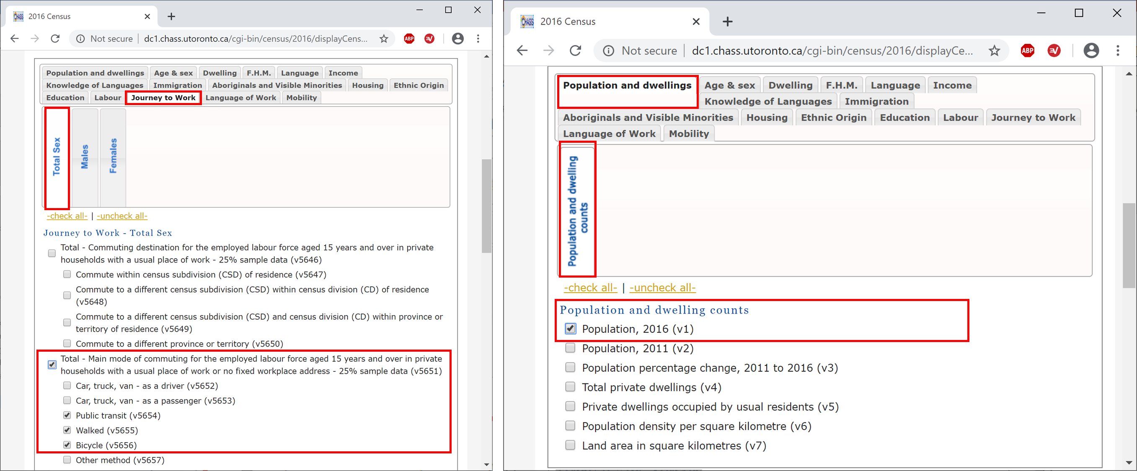

Join your data table to your census tract layer for 2016 (see Q5 for that procedure). Answer the following questions [1 point each]:

* 1. In how many census tracts do more people bike than walk as their mode of transportation to work?
  2. In how many census tracts do more people walk than bike as their mode of transportation to work?
  3. What is the average after-tax income of census tracts where more people walk than bike to work?
  4. What is the average after-tax income of census tracts where more people bike than walk to work?
  5. Create a map showing the ratio of biking to walking and explain the pattern you observe? (You need a map and explanation).
  6. Create a map showing the proportion of the total population that bikes to work and explain the pattern that you observe.

1. [7 points] Download from the 2016 tables in the Canadian Census Analyser (see Q2) the following variables:

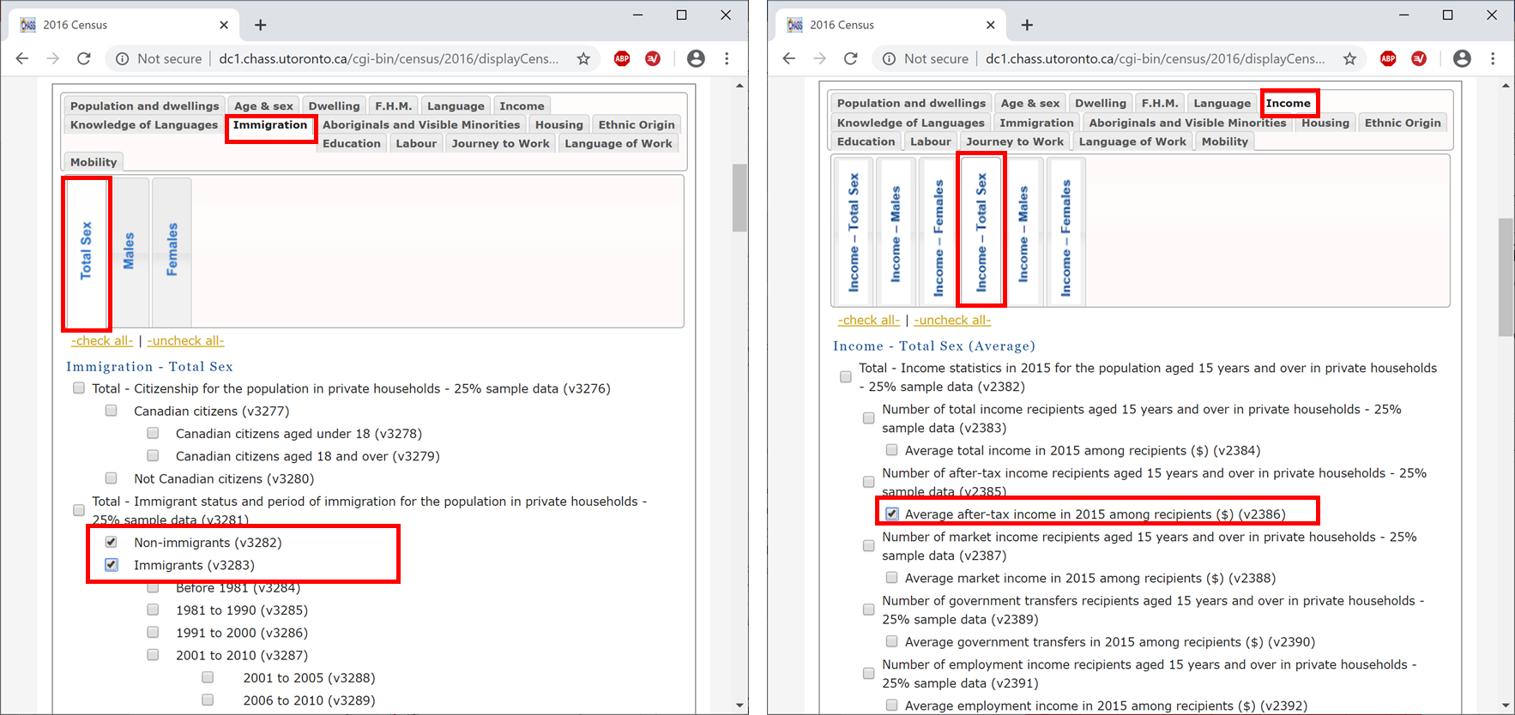

Join your data table to your census tract layer for 2016 (see Q5 for that procedure). Answer the following questions [1 point each]:

1. In how many census tracts are there more immigrants than non-immigrants?
2. In how many census tracts is the ratio of immigrant to non-immigrant greater than 0.25?
3. In how many census tracts does the ratio of immigrant to non-immigrant greater than 0.5?
4. In how many census tracts does the ratio of immigrant to non-immigrant greater than 0.4?
5. What is the average income of census tracts that have an immigrant/non-immigrant population ratio of greater than 0.4?
6. What is the average income of census tracts that have an immigrant / non-immigrant population ratio less than 0.4?
7. What is the pattern of immigrant / non-immigrant population ratio?